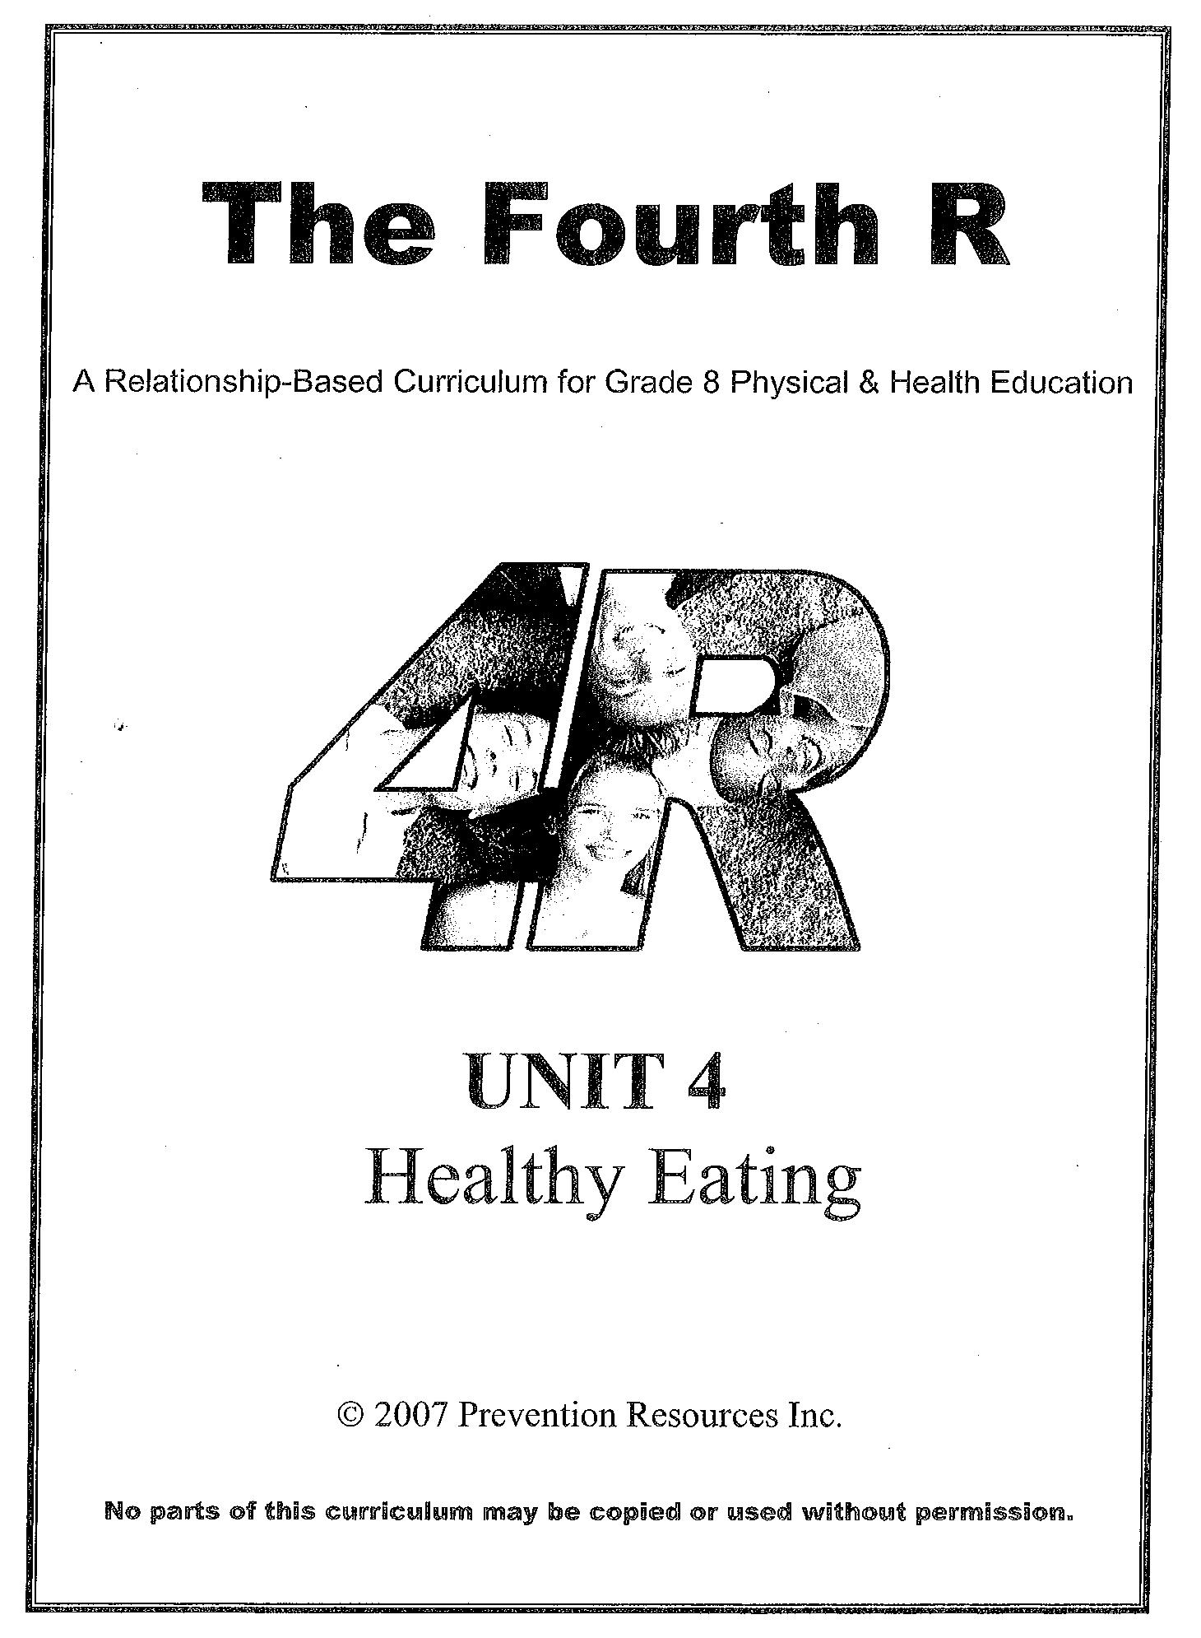

Unit 4 - Lesson 1

Lesson #1
Myths and Facts About Healthy and Unhealthy Eating

Specific Expectations:
Students will:
- analyse the effects of under-eating (ex. as a result of bulimia or sports dieting) and overeating (ex. obesity) on health and well-being;
- identify ways to maintain a healthy body weight (ex. physical activity)

Materials:
- Guidelines for Health Class poster (if already created) or you will need chart paper/Bristol board and markers to create a new one
- Box to be used as a question box
- Question Box (1.0 OH)
- Small pieces of scrap paper (1 per student) for the question box questions
- Overhead projector
- Bulletin board space for “Question Box Answers”
- One sign for each of the four corners of the room (ABSOLUTELY, YES BUT...., NO BUT..., NO WAY)
- Masking tape
- Appendix A - Four Corners
- Food and Activity Journal (1.1 H)
- Food and Activity Journal - Reference (1.2 OH/REF)
- Measurement tools: measuring cup, teaspoon, tablespoon, deck of cards

Teaching/learning Strategies:
- Some strategies have been adapted from Beyond Monet, by Barrie Bennett and Carol Rolheiser (2001), Think Literacy: Cross Curricular Approaches, (2005) and Tribes, by Jeanne Gibbs, 2001.

217
Myths and Facts About Healthy and Unhealthy Eating

- Activity #1 - Review Guidelines for Health Class

- Review classroom expectations
Guidelines for Health Class
1. Respect others (ex. active listening, showing respect for comments made by other students)
2. No name rule (ex. when providing an example, don’t use names)
3. Participate (ex. try to be an active participant during discussions)
for the healthy living unit.
Explain to students that this unit is called
“Healthy Eating”. You may
choose to have some
expectations for health class
posted in the room if similar ones
have not already been
discussed with the class. It may be helpful
to develop some of these
guidelines for health class
together with the students.
Some of the guidelines may include examples as outlined in the text box. It will be particularly important to ensure that the “guidelines” for class will provide a safe classroom environment so that students who are overweight or underweight do not feel stigmatized or uncomfortable about topics being discussed. (5 min)

- Activity #2 - Question Box Guidelines

- It is important to provide an anonymous question box for the class, since students who suffer from negative body image and are embarrassed by it probably won’t ask questions in front of other students in class.

- Explain to students that during this health unit, they will have an opportunity to ask anonymous questions related to healthy eating, unhealthy eating and active living. Place the overhead, “Question Box” (1.0 OH) on the overhead projector and read through the information with students. After reviewing the guidelines for the question box, show students the box and hand out a small piece of scrap paper to each student. Tell students to keep the paper until the end of the class, when it will be collected for the question box. (5 minutes)

- Activity #3 - Four Corners (see Appendix A)

- Read through Appendix A for a step by step description of the activity. Use the statements below when working through the activity with the students. (20 minutes)

218
Unit 4 - Lesson 1

- Statements and Possible Discussion Ideas:

1. It’s important to eat three meals per day.

Discussion ideas:
- skipping meals may lead to fatigue/low energy
- skipping meals may lead to snacking on food with little nutritional value because you feel “so hungry”
- better to eat three meals and a couple of snacks to maintain energy and increase BMR (basal metabolic rate, ex. amount of calories burned increases if you eat more, but it needs to be healthy eating!)
- may not be eating enough calories for healthy function of body

2. Grade 8 students need to be active 15-20 minutes per day.

Discussion ideas:
- 90 minutes daily is recommended for youth
- this does not have to be done all at once (begin with 5 minute intervals throughout the day and work up from there)
- being active means being active in ways that you enjoy

3. Going on a diet is a good way to maintain a healthy body weight.

Discussion ideas:
- most people who go on a diet gain the weight back when they go off the diet
- it is better to change your lifestyle by increasing your physical activity and eating healthy food while limiting food high in sugar, salt and fat

4. Eating chocolate is bad for you!

Discussion ideas:
- eating chocolate EVERY day will increase your caloric intake but eating anything in moderation is okay

- Activity #4 - Food and Activity Journal

- Explain to students that you would like them to record information about everything they eat, as well as their activity level, for the next few days so that they will be

219

Myths and Facts About Healthy an Unhealthy Eating

able to analyse what they are eating and set some goals. Hand out a copy of the “Food and Activity Journal” (1.1 H) to each student. Read through the “sample day” to explain to students that they need to write their information in detail, and that they need to record information about everything they eat and drink during the day, as well as any type of physical activity in which they take part during the day. Refer to the “measurement” section at the bottom and review those measurements with the students. In addition, you may want to bring in a measuring cup, teaspoon, tablespoon and deck of cards so that students see a visual representation of the measurements. Ask students to ignore the bottom part of the handout (servings) for today, but that they will have an opportunity in class tomorrow to complete that part of the handout. Instruct students to complete the table for what they have eaten today so far. (15 minutes)

*At the end of class, remember to collect questions from students for the question box!

- Homework assignment - Food Journal

- Students will need to complete the remainder of the food journal for today after dinner. Remind students to bring their food journal to the next health class.

220
Unit 4 - Lesson 1

1.0 OH

Question Box

At the end of every health class, each student will be provided with a small piece of paper.

All students must write something on the paper! The activity is to be used to ask a question about healthy eating, unhealthy eating or active living. If questions are asked about unrelated topics, they will not be answered.

If you don’t have a question that day, you will still need to write something on the paper....if you want, you can just write “hello” to your teacher!

The teacher will come around to each desk and collect the question from each student at the end of the health class.

All answers will be written by the teacher and will be up on the bulletin board the next day.

It is important that all students read the answers to the questions once they are on the bulletin board because they may be important for the culminating activity. The answers will stay up on the bulletin board for the entire unit so that students may read the information at any time during the day.

221
Unit 4 - Lesson 1
1.2 H Name:____________________
Food and Activity Journal
 | Sample Day | Day 1 - today | Day 2 | Day 3
Breakfast | - 1/2 cup Corn bran cereal with 1/2 cup milk (1 serving grain/1/2 serving dairy)  -1 banana (1 fruit)
Lunch | - 1/2 cup milk (1/2 dairy)  - sandwich (2 pieces of bread, 2 slices turkey, 1 small piece of lettuce, 1 tbsp butter (2 grain, 1 meat, 1/2 veg, other)  - 1 apple (1 fruit)
Dinner | - 1 glass of milk (1 cup) (1 dairy)  - 1 pork chop, barbecued (1 meat)  - 1/2 cup green beans (1 serving vegetables)  - 1/2 cup corn (1 serving veg)
Snacks | - 1/2 cup raw carrots (1 serving veg)  - 4 small glasses of water (4 cups)  - 1 can Coke (OTHER)  -1 orange (1 fruit)
Physical Activity | - lunch - tag (15 min)  - lunch - tether ball (15 min)  - walk to/from school (30 min)  - basketball game (30 min playing time)  (total = 90 minutes)
Servings: Fruit/vegetables
Servings: Grain
Servings: Milk and Alternatives
Servings: Meat and Alternatives
Measurements: *deck of cards = 1 serving meat *adult fist = 1 cup *thumb from knuckle to end= tablespoon
222
Unit 4 - Lesson 1
1.2 OH/REF
Food and Activity Journal - Reference
 | Sample Day | Day 1 - today | Day 2 | Day 3
Breakfast | - 1/2 cup Corn bran cereal with 1/2 cup milk (1 serving grain/1/2 serving dairy)  -1 banana (1 fruit)
Lunch | - 1/2 cup milk (1/2 dairy)  - sandwich (2 pieces of bread, 2 slices turkey, 1 small piece of lettuce, 1 tbsp butter (2 grain, 1 meat, 1/2 veg, other)  - 1 apple (1 fruit)
Dinner | - 1 glass of milk (1 cup) (1 dairy)  - 1 pork chop, barbecued (1 meat)  - 1/2 cup green beans (1 serving vegetables)  - 1/2 cup corn (1 serving veg)
Snacks | - 1/2 cup raw carrots (1 serving veg)  - 4 small glasses of water (4 cups)  - 1 can Coke (OTHER)  -1 orange (1 fruit)
Physical Activity | - lunch - tag (15 min)  - lunch - tether ball (15 min)  - walk to/from school (30 min)  - basketball game (30 min playing time)  (total = 90 minutes)
Servings: Fruit/vegetables | 6.5 servings (* 6 servings are required)
Servings: Grain | 3 servings (*6 servings are required)
Servings: Milk and Alternatives | 2 servings (* 3-4 are required)
Servings: Meat and Alternatives | 2 servings (* 1-2 servings are required)
Measurements: *deck of cards = 1 serving meat *adult fist = 1 cup *thumb from knuckle to end= tablespoon
223
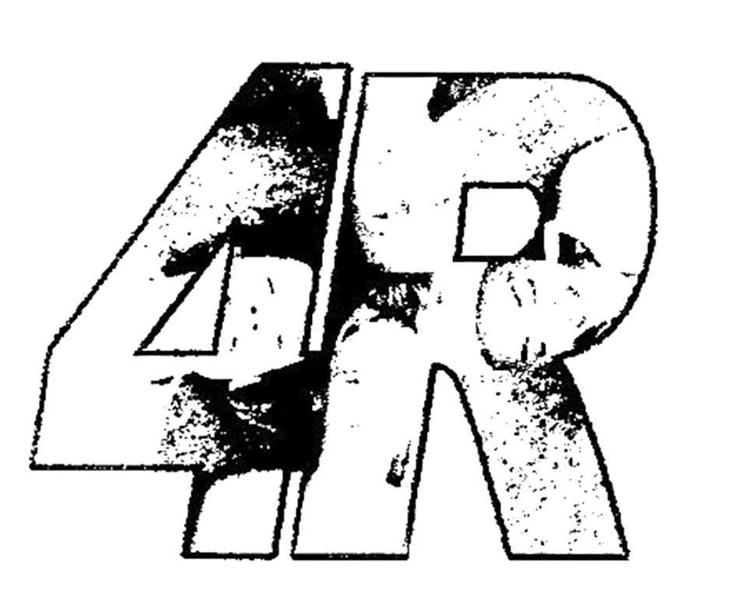

224
Unit 4 - Lesson 2

Lesson #2
Understanding the Food Guide and Activity Guide

Specific Expectations:
Students will:
- Analyse the effects of under-eating (ex. as a result of bulimia or sports dieting) and overeating (ex. obesity) on health and well-being;
- Identify ways to maintain a healthy body weight (ex. physical activity)

Materials:
- Bulletin board for “Question Box” responses
- Small pieces of scrap paper (1 per student) for “Question Box”
- Question Box
- Students will need Food and Activity Journal (1.1 H) from previous class
- Food and Activity Journal - Reference (1.2 OH/REF)
- Eating and Active Living - Mind Map (2.0 H)
- Rubric for Mind Map (2.1 H)
- Eating and Active Living - Mind Map Reference (2.2 REF)
- Blank paper 11x17 (one for each student in the class)
- Glue sticks
- Canada’s Food Guide (2.3 H)
- Physical Activity for Youth (2.4 H)
- Physical Activity for Youth (2) (2.5 H)
- Overhead projector
- Appendix B - Mind Map

* Note: the Food Guide and Activity Guide can be ordered online at www.phac-aspc.gc.ca/pau- uap/fitness/order.html

Teaching/learning Strategies:
- Some strategies have been adapted from Beyond Monet, by Barrie Bennett and Carol Rolheiser (2001), Think Literacy: Cross Curricular Approaches, (2005) and Tribes, by Jeanne Gibbs, 2001.

225
Understanding the Food Guide and Activity Guide

- Activity #1 - Question Box

- Remind students that you have posted questions and answers on the bulletin board and that students should take the time to read the questions and responses at some time during the school day. Hand out a small piece of paper to each student. Remind students that each person will need to hand in the paper to put in the question box at the end of the class, and that it must have something written on it. (2 minutes)

- Activity #2 - Mind Map - Eating and Active Living

- Part A - Healthy Eating Research
- Hand out a copy of the “Eating and Active Living - Mind Map” (2.0 H) and one piece of 11 x 17 paper to each student, as well as some glue sticks. Ask students to glue the Mind Map into the centre of the page in their notebooks. The mind map has already been started with some key topics for students. Students will be using the mind map to continue with their note taking in this unit, so they will need to make sure they have the handout (2.0 H) with them for each health class. The mind map will be collected on day 7 of the unit, to be marked for completion as outlined in the rubric (2.1 H). See Appendix B for Mind Map instructions. During class, the focus for the mind map will be on healthy eating. Read through the part of Canada’s Food Guide (2.3 H) that relates to the students in the class. Ask students to work with a partner to add to the part of the mind map that expands out from the bubble labeled “Canada’s Food Guide.” (10 minutes)

- Part B - Sharing Information about Healthy Eating
- After students have had time to complete some of the information on their Mind Maps related to Canada’s Food Guide, ask volunteers to share with the class what they added to their Mind Maps. The teacher may want to use the “Eating and Active Living - Reference” (2.2 REF) to refer to some possible responses. (5 minutes)

- Part C - Active Living Research
- Hand out a copy of “Physical Activity for Youth” (2.4 H) and Physical Activity for Youth (2)” (2.5 H) to each student. While students are working with the same partner, ask them to read through the booklet and decide

226
Unit 4 - Lesson 2

on the most important ideas they can connect to the “active living” bubble on the mind map. (10 minutes)

- Part D - Sharing Information about Active Living
- Ask volunteers to share what they have drawn/written on their Mind Maps as it relates to active living. The teacher may want to refer to (2.2 REF) to add to the discussion. (5 minutes)

- Activity #3 - Homework Discussion - Food and Activity Journal

- Ask students to take out their “Food and Activity Journal” (1.1 H) from the previous class. Ask if there are any questions or concerns that have come up while students have been filling out their journals. Check homework to ensure that all students have been keeping track of their eating and exercise. (2-3 minutes)

- Activity #4 - Canada’s Food Guide - Applying it to the Food and Activity Journal

- Explain to students that the first part of the journal you are going to focus on is the part related to eating. Ask students to refer to their copy of “Canada’s Food Guide” (2.3 H). Review the parts of the Food Guide that relate to “number of servings” and what that means for each of the food groups as outlined on the food guide. Remind students of the different measurements and serving sizes that were discussed in the previous class. Put a copy of the “Food and Activity Journal - Reference” {1.2 OH/REF) on the overhead projector, and work through the sample day, explaining to students how you counted up the serving sizes. Ask students to complete the bottom section of their “Food and Activity Journal” (1.1 H) by identifying the number of servings of each food group they ate for day one. Have students circle any of the number of servings on their “Food and Activity Journal” (1.1 H) that match with the recommended number of servings on the food guide. Explain to students that some foods such as butter, oil, pop, etc. are considered as “other” because they are not a part of Canada’s Food Guide, due to their lack of nutritional value. Students may work on this until the end of class. If there isn’t enough time for students to complete the work, they may complete it for homework. (15 minutes)

* At the end of class, collect a piece of paper from each student for the Question Box.

227
Understanding the Food Guide and Activity Guide

- Homework Assignment -
- 1. Students will need to continue recording their food intake (including the number of servings) and their physical activity,
- 2. Students must bring their Mind Map and Food and Activity Journal to the next health class.

228
Unit 4 - Lesson 2

2.0 H

Eating and Active Living - Mind Map
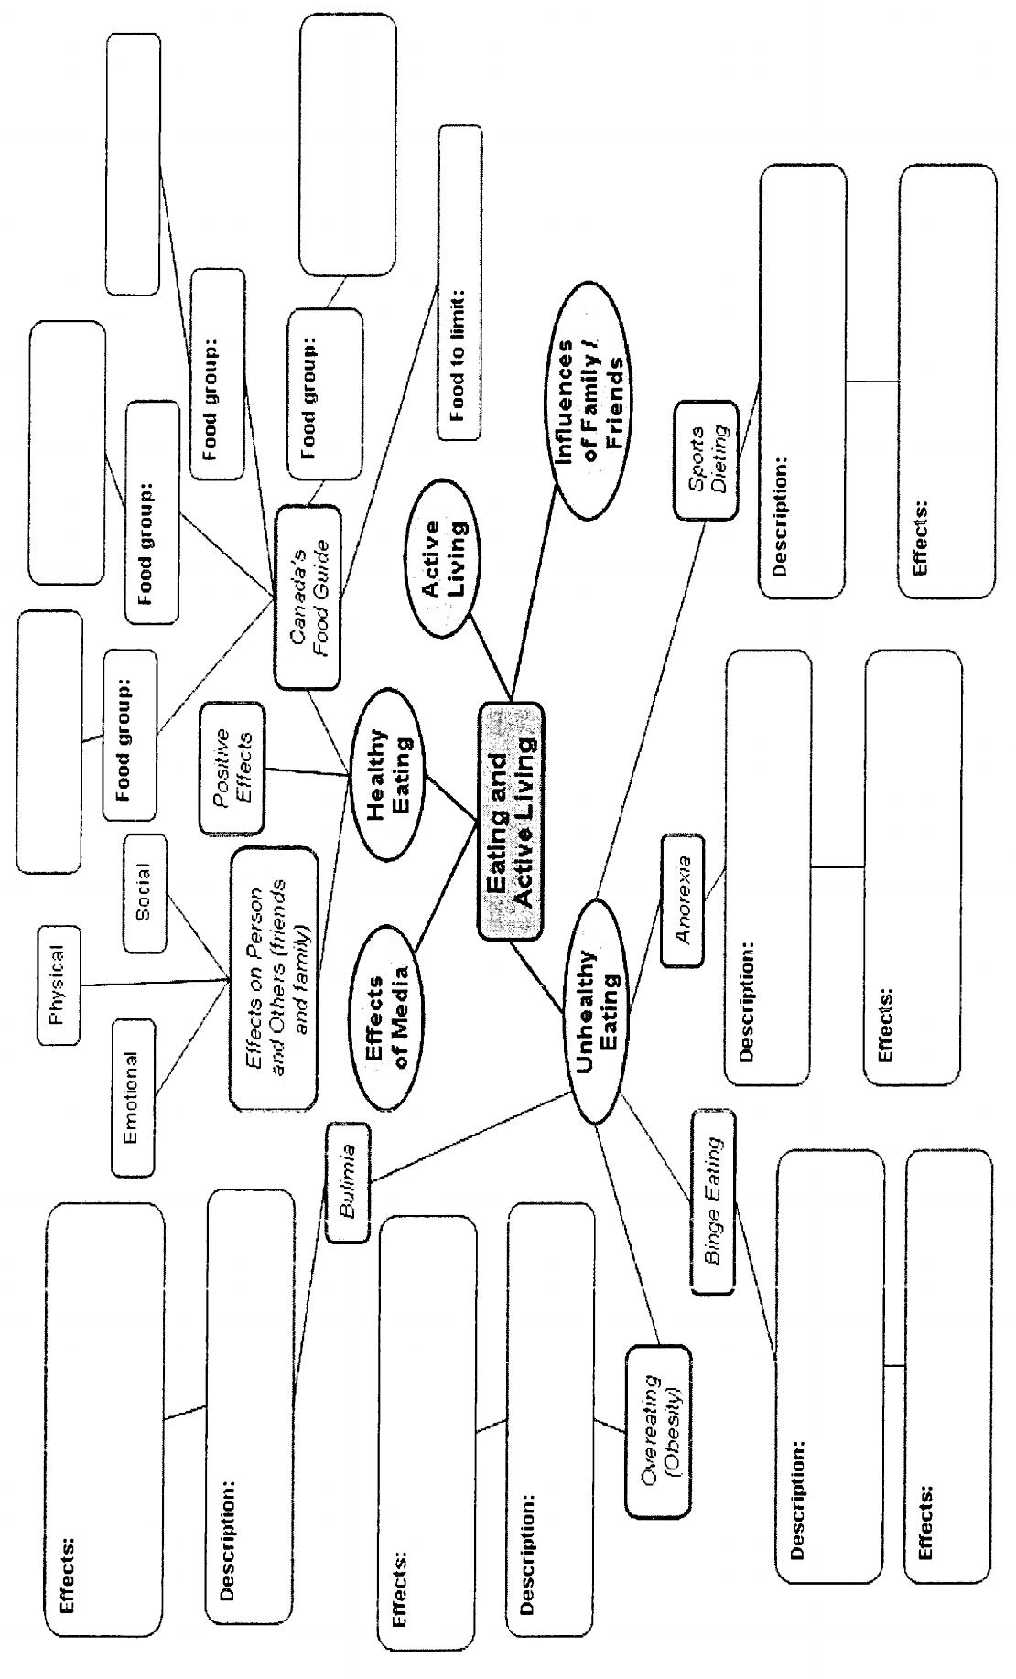
229
Understanding the Food Guide and Activity Guide

2.1 H

Rubric for Mind Map

Knowledge/SkiIls | Level 1 | Level 2 | Level 3 | Level 4
Communication of Required Knowledge (Communication) | -communicates poorly, making many errors or omissions | - communicates with some clarity, making some errors or omissions | - communicates clearly and precisely, making few errors or omissions | - communicates clearly and precisely, making no or almost no errors or omissions
Communication of Required Knowledge (Communication) | -rarely uses appropriate terminology | - sometimes uses appropriate terminology | - usually uses appropriate terminology | - uses appropriate and varied terminology
Understanding of Concepts (Knowledge) | -shows understanding of few of the required concepts taught  - major errors or omissions | - shows understanding of some of the required concepts taught  - several minor errors or omissions | - shows understanding of most of the required concepts taught  - a few minor errors or omissions | - shows understanding of all or almost all of the required concepts taught  - practically no errors or omissions
(Ontario Curriculum, Grades 1-8, Health and Physical Education, 1998)

230
Unit 4 - Lesson 2

2.2 Ref

Eating and Active Living - Mind Map Reference

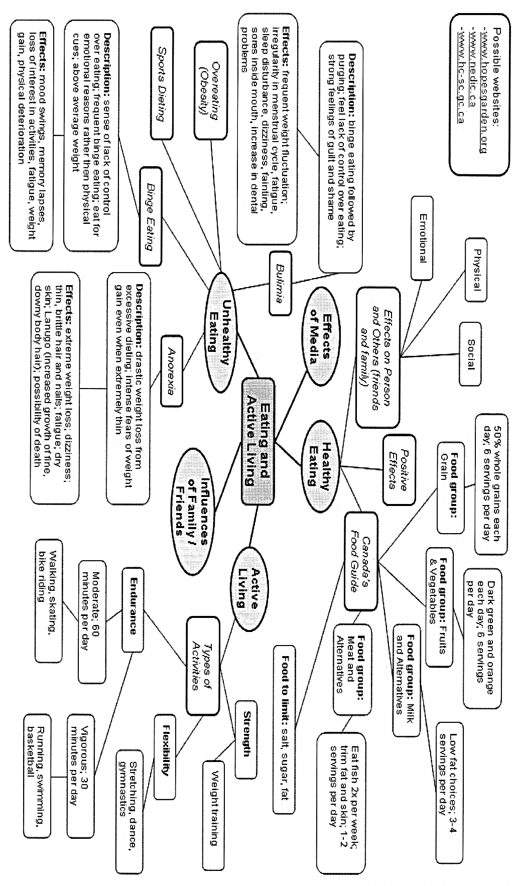

231
Understanding the Food Guide and Activity Guide

2.3 H

Canada’s Food Guide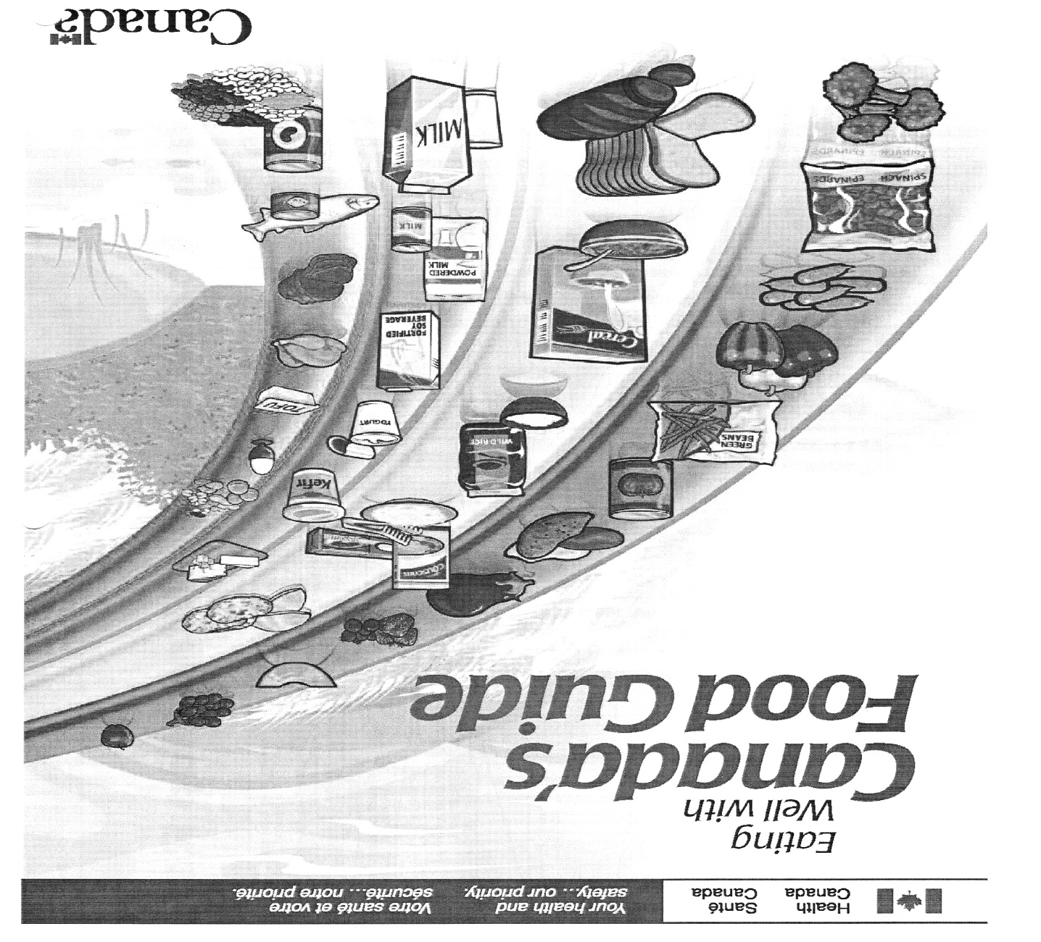

232
Unit 4 - Lesson 2

Recommended Number of Food Guide Servings per Day

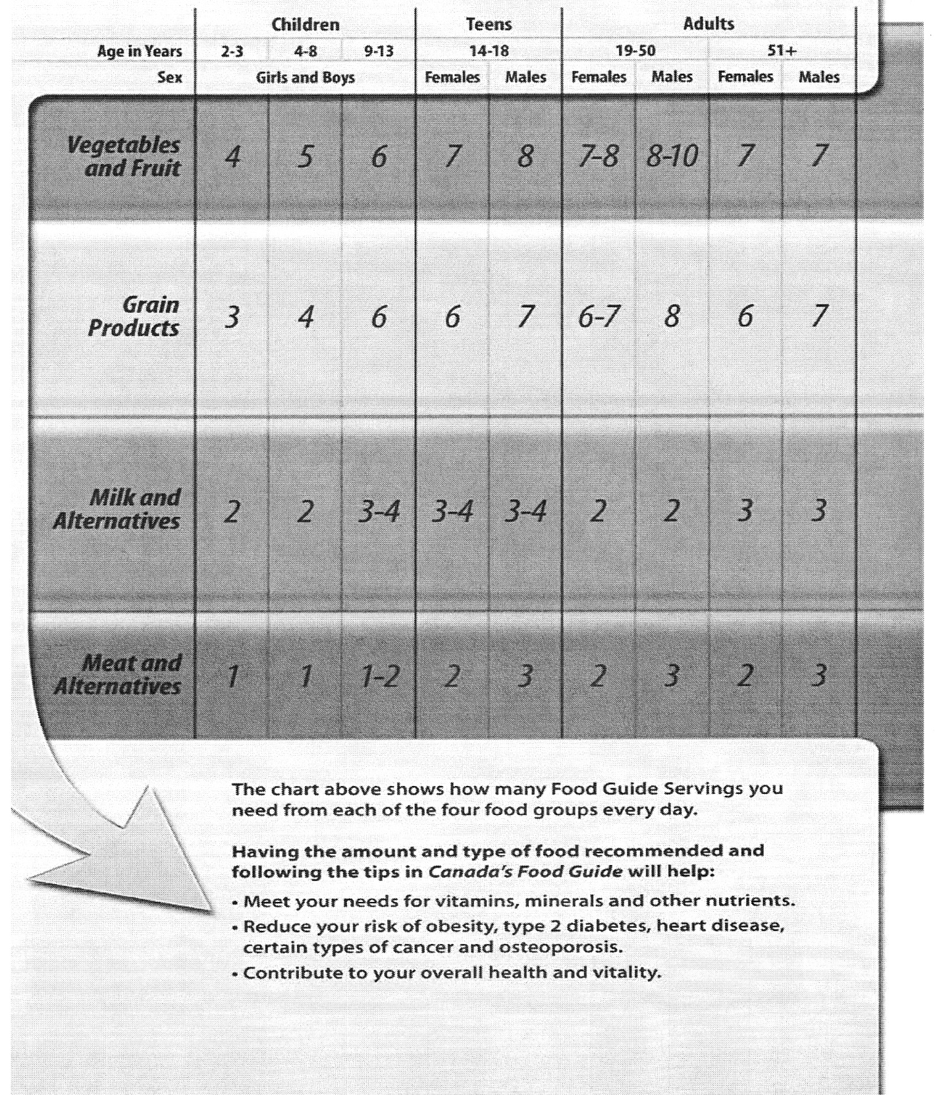

233
Understanding the Food Guide and Activity Guide

What is One Food Guide Serving?

Look at the examples below.

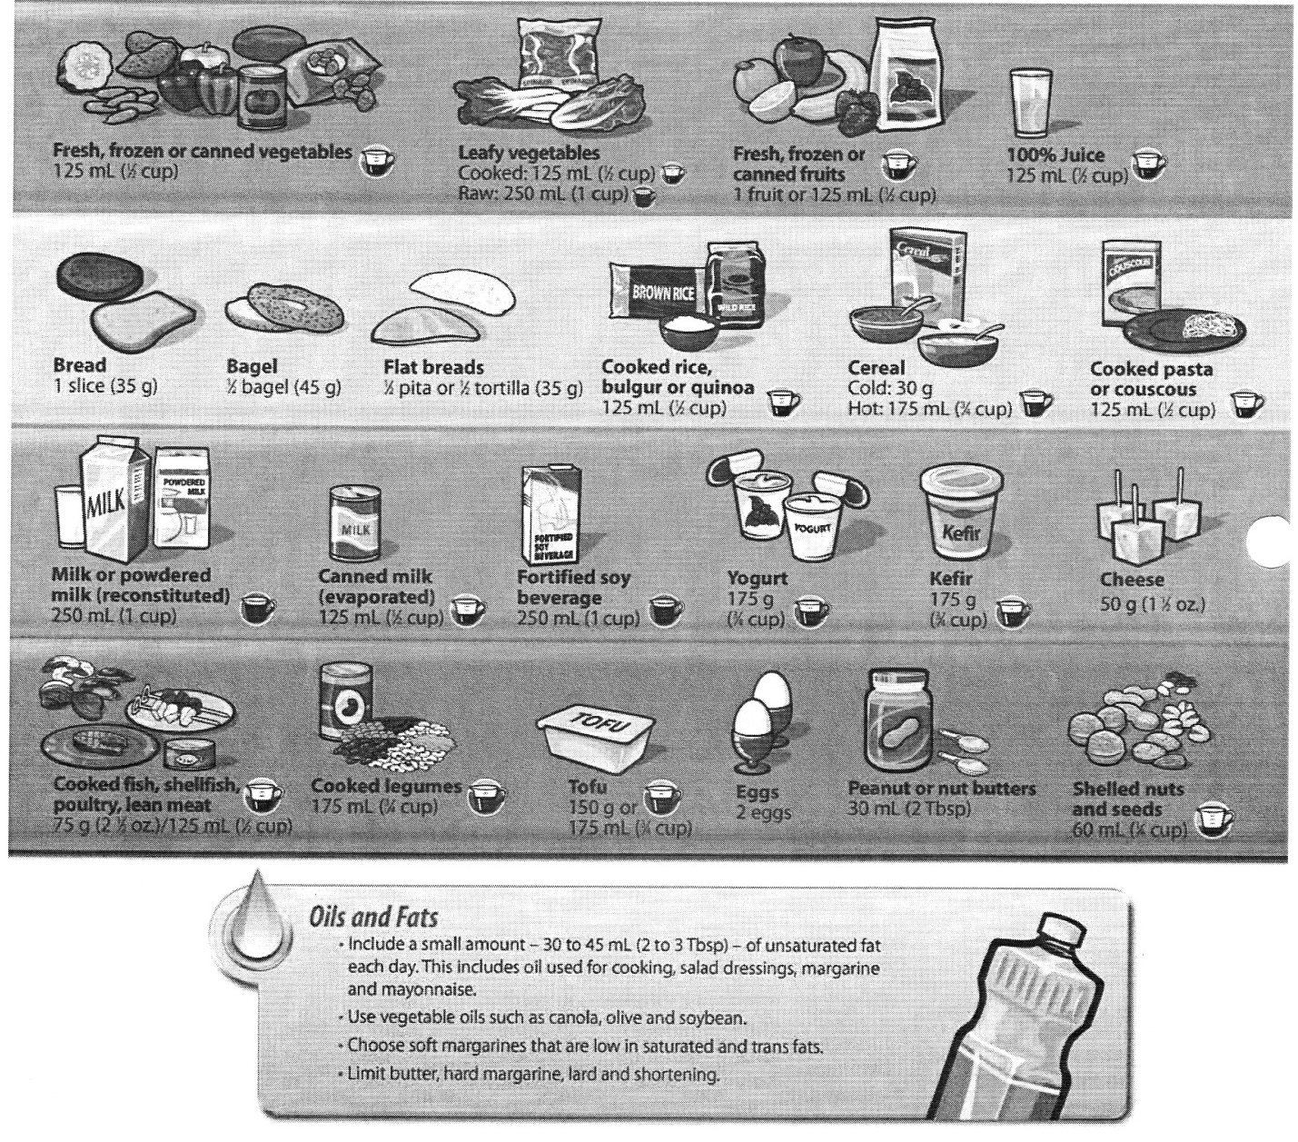

234
Unit 4 - Lesson 2

Make each Food Guide Serving Count…

Wherever you are - at home, at school, at work or when eating out!

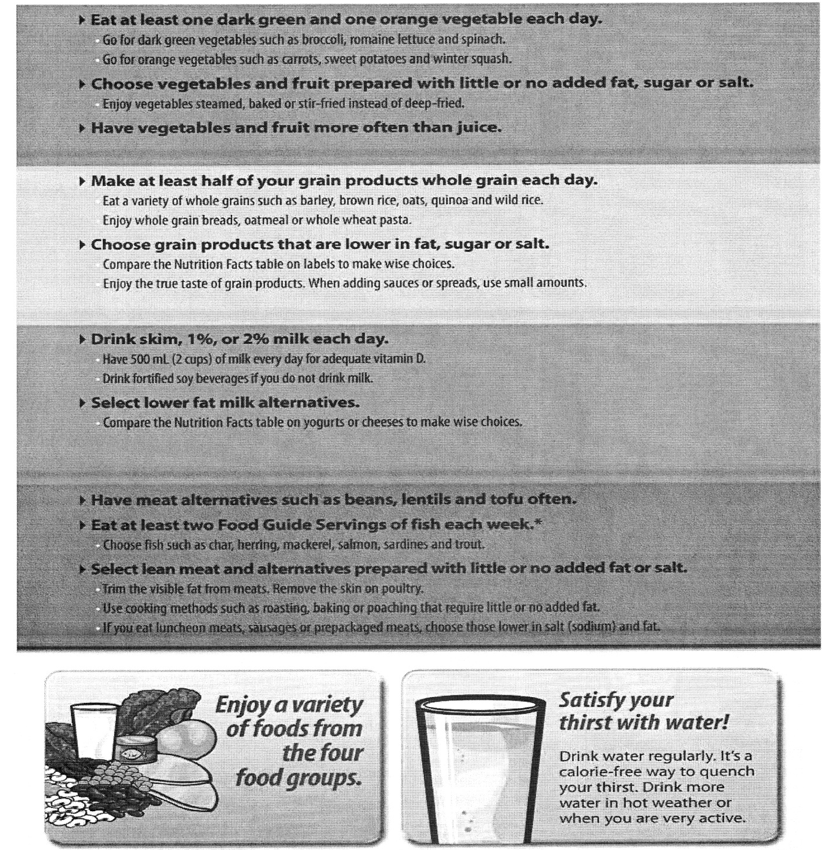

* Health Canada provides advice for limiting exposure to mercury from certain types of fish. Refer to www.healthcanada.gc.ca for the latest information.

235
Understanding the Food Guide and Activity Guide

Advice for different ages and stages…

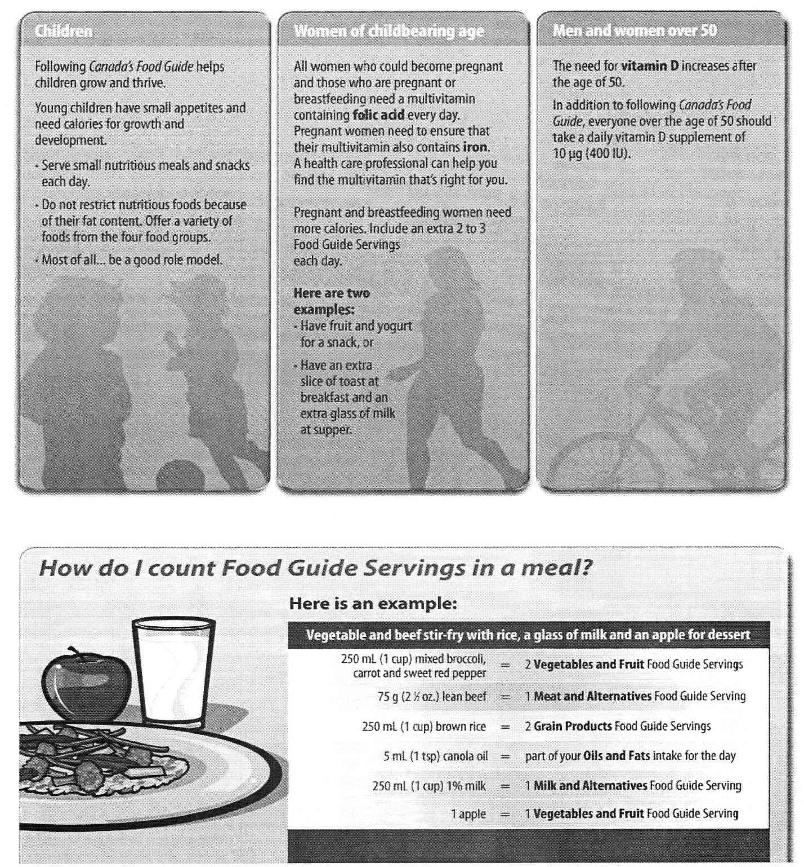

236
Unit 4 - Lesson 2

Eat well and be active today and every day!

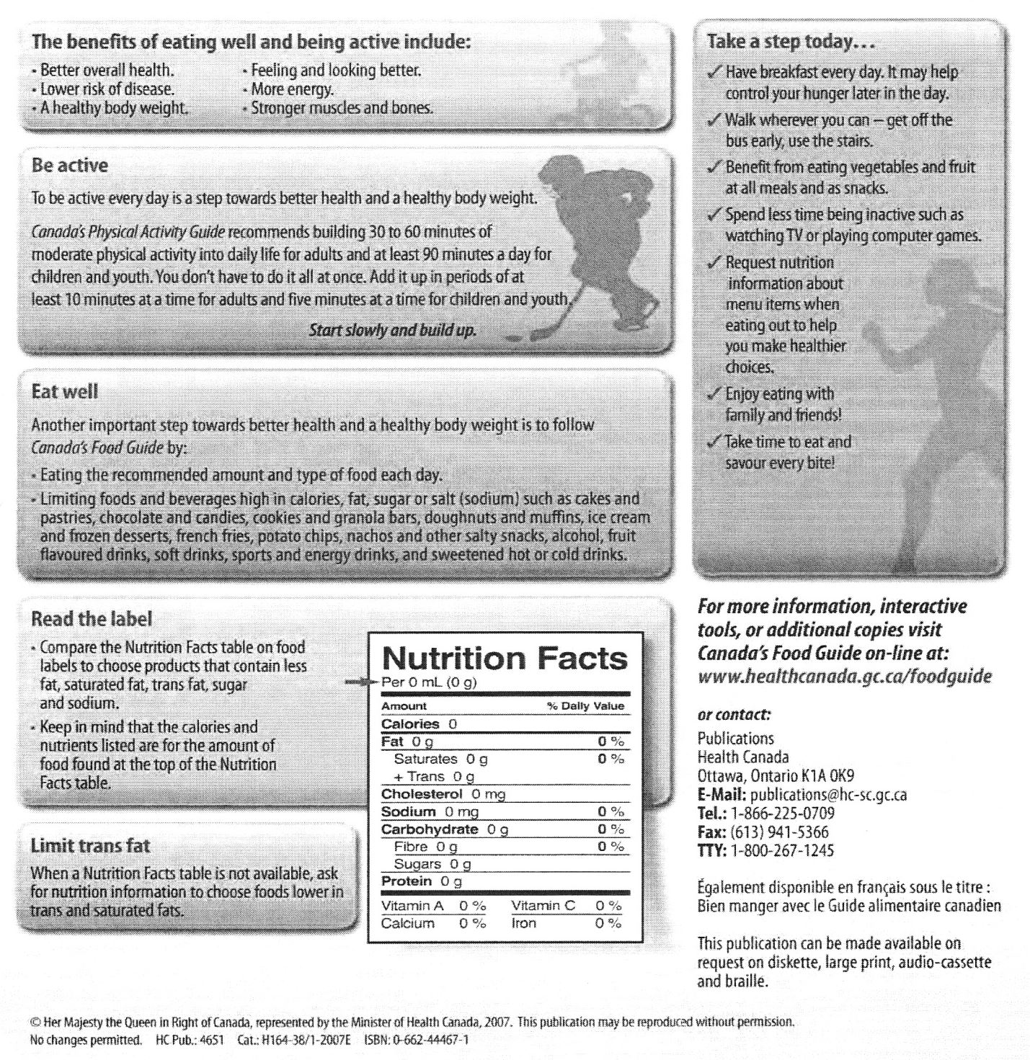

237
Understanding the Food Guide and Activity Guide

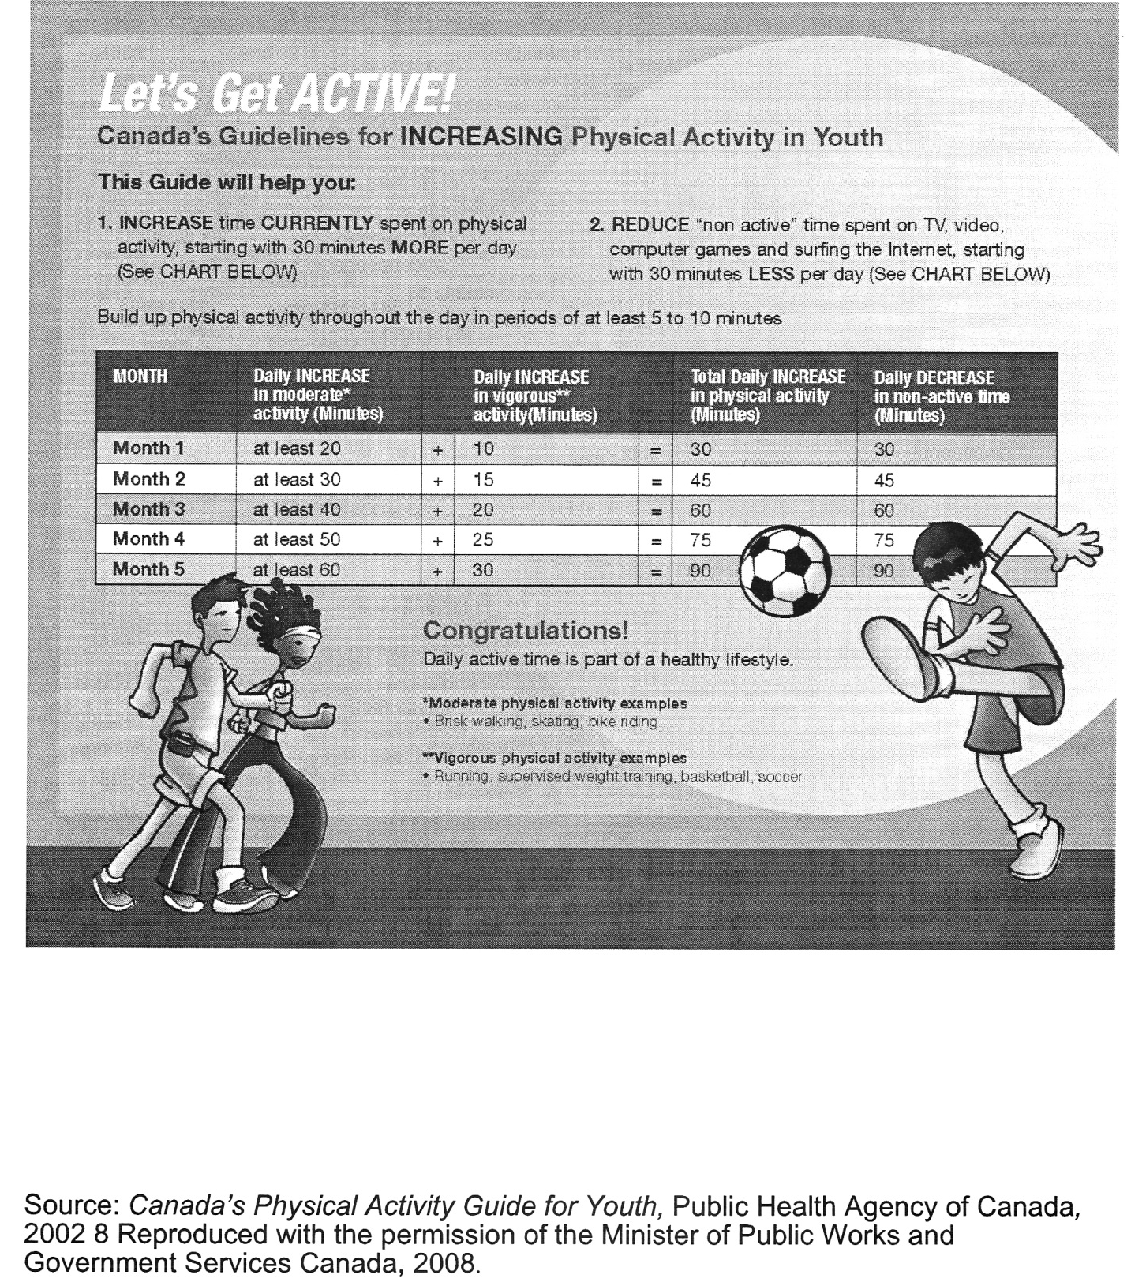

238
Unit 4 - Lesson 2

2.5 H

Physical Activity for Youth (2)

Benefits of physical activity:
- helps maintain and achieve a healthy body
- promotes well-being and reduces stress
- helps build and maintain healthy bones, muscles and joints
- improves fitness
- promotes good posture and balance
- improves confidence and self esteem
- lowers risk of developing chronic diseases such as heart disease and diabetes in adulthood

How do I go about being more active?
- start slowly and build up, adding an extra 30 minutes of activity each day
- add physical activity throughout the day in periods of at least 5-10 minutes.
- 90 minutes of moderate and vigorous physical activity a day is needed for optimal health
- choose more active alternatives (ex. take the stairs instead of using an elevator)
- reduce the amount of time you spend being non-active (watching TV, playing video games, surfing the net, text messaging friends, etc.). Start by decreasing the time by 30 minutes each day and building up to 90 minutes.

Suggestions for Physical Activity: Choose activities that are fun and enjoyable for you and your friends and family. You’re more likely to participate in activities you like!
- walk to school
- play with your pet or take it for a walk
- organize a game with some friends (for example, soccer)
- dance to music
- cold weather activities:
- skating
- tobogganing
- building a snowperson
- warm weather activities:
- bicycling
- swimming
- playing catch
- tag
- baseball

(Adapted from: http://www.healthunit.com/, http://www.healthylivinginfo.ca/physicalactivity.htm)

239

240
Unit 4 - Lesson 3

Lesson # 3
Balancing Healthy Eating and Active Living

Specific Expectations:
Students will:
- analyse the effects of under-eating (ex. as a result of bulimia or sports dieting) and overeating (ex. obesity) on health and well-being;
- identify ways to maintain a healthy body weight (ex. physical activity);
- adopt personal food plans, based on nutritional needs and personal goals, to improve or maintain their eating practices.

Materials:
- Computer Lab (for approximately 20 minutes)
- Question Box
- Small pieces of scrap paper (1 per student) for “Question Box”
- Food and Activity Journal (1.1 H)
- Food and Activity Journal- Reference (1.2 OH/REF)
- Overhead projector
- Eating and Active Living - Mind Map (2.0 H)
- Eating and Active Living - Mind Map (2.2 REF)
- Unhealthy Eating Research (3.0 OH)
- Teams Game Tournament- Questions (3.1 H)
- Teams Game Tournament - Answers (3.2 REF)
- Deck of cards for each group of four students (only need to have Ace to 7 of each suit) (see Appendix C) - Extension Activity
- Appendix C - Teams Game Tournament (for Extension Activity)
- Media Influence on Eating and Exercise (3.3 H)

Teaching/learning Strategies:
- Some strategies have been adapted from Beyond Monet, by Barrie Bennett and Carol Rolheiser (2001), Think Literacy: Cross Curricular Approaches, (2005) and Tribes, by Jeanne Gibbs, 2001.

241
Balancing Healthy Eating and Active Living

- Activity #1 - Question Box

- Remind students that you have posted questions and answers on the bulletin board and that students should take time to read the questions and responses at some time during the school day. Hand out a small piece of paper to each student. Remind students that each person will need to hand in the paper to put in the question box at the end of the class, and that it must have something written on it. (2 minutes)

- Activity #2 - Unhealthy Eating Research

- Part A - Assignment Explanation

- Divide students into ten groups. Put the “Unhealthy Eating Research” (3.0 OH) overhead up on the overhead projector. Assign a topic to each group (there will be two groups with each topic). Ask students to take out their “Eating and Active Living Mind Map” (2.0 H), and to identify each of the topics (as outlined on the overhead) on their Mind Map under the topic of “Unhealthy Eating.” Explain to students that for their topic, they will be responsible for researching all of the effects as listed on the Mind Map. Point out the websites on the overhead and ask students to record them on the back of their Mind Maps, because students will find these websites useful in their research. Explain to students that they will be going to use the computer lab/library to research the topic assigned to each group, and that each group is to complete their Mind Map based on their topic. (5 minutes)

- Part B - Library Research

- Take students to the computer lab. One person from the group will be navigating the websites on the computer while the others take on the role of recording on one Mind Map for the group. Tell students that at the end of the research time, they will be presenting their information to the class (15 minutes)

- Part C - Sharing Information

- Take students back to the classroom. Ask each group to choose a speaker to present the information the group found

242

Unit 4 - Lesson 3

in their research of their topic. While each group presents, others should record the information on their own Mind Maps so that they have information recorded about all of the types of unhealthy eating. The teacher may want to refer to 2.2 REF to add to the discussion. At the end of the sharing session, conclude by stating that eating disorders can have a very serious impact on someone’s life, so it is important to establish healthy eating and activity habits. (10 minutes)

- Activity #3 - Review Homework (Food Journal)

- Ask students to take out their Food and Activity Journal (1.1 H) and ask them if they have any questions related to what they have been recording. Remind students that tomorrow, they will need their Food and Activity Journal during class because they will have an opportunity to set goals for themselves around healthy eating and active living. (5 minutes)

- Homework Assignment - Media Influence on Eating and Exercise

- Hand out a copy of “Media Influence on Eating and Exercise” (3.3 H) to each student. Explain to students that over the next two nights, you would like them to record the information as outlined on the handout. If possible, students should try to watch one hour of television each night in order to complete the handout. This handout is due in class on day 5 of the unit. (5 minutes)

* At the end of class, remember to collect questions from students for the question box!

- Extension Activity - Teams Game Tournament

*You may want to do this activity with the class if you feel that they need further understanding of the Food Guide and Physical Activity Guide.

- Explain to students that in order to review Canada’s Food Guide and the Physical Activity Guide, students will have an opportunity to play a review game called Teams Game Tournament. See Appendix C for instructions. (25 minutes)

243
Balancing Healthy Eating and Active Living

3.0 OH

Unhealthy Eating Research

1. Unhealthy Eating Topics:
- Bulimia
- Anorexia Nervosa
- Overeating (Obesity)
- Binge Eating
- Sports Dieting

2. Effects on the Person and Others (friends and family):
- Physical
- Social
- Emotional

3. Possible websites:
www.hopesgarden.org
www.nedic.ca
www.hc-sc.gc.ca

244
Oral Presentation Rubric
TRAIT | 4 | 3 | 2 | 1
NONVERBAL SKILLS
EYE CONTACT | Holds attention of entire audience with the use of direct eye contact, seldom looking at notes. | Consistent use of direct eye contact with audience, but still returns to notes. | Displayed minimal eye contact with audience, while reading mostly from the notes. | No eye contact with audience, as entire report is read from notes.
BODY LANGUAGE | Movements seem fluid and help the audience visualize. | Made movements or gestures that enhance articulation. | Very little movement or descriptive gestures. | No movement or descriptive gestures.
POISE | Student displays relaxed, self-confident nature about self, with no mistakes. | Makes minor mistakes, but quickly recovers from them; displays little or no tension. | Displays mild tension; has trouble recovering from mistakes. | Tension and nervousness is obvious; has trouble recovering from mistakes.
COMMENTS:

VERBAL SKILLS
ENTHUSIASM | Demonstrates a strong, positive feeling about topic during entire presentation. | Occasionally shows positive feelings about topic | Shows some negativity toward topic presented. | Shows absolutely no interest in topic presented.
ELOCUTION | Student uses a clear voice and correct, precise pronunciation of terms so that all audience members can hear presentation. | Student’s voice is clear. Student pronounces most words correctly. Most audience members can hear presentation. | Student’s voice is low. Student incorrectly pronounces terms. Audience members have difficulty hearing presentation. | Student mumbles, incorrectly pronounces terms, and speaks too quietly for a majority of students to hear.
COMMENTS:

CONTENT
SUBJECT KNOWLEDGE | Student demonstrates full knowledge by answering all class questions with explanations and elaboration. | Student is at ease with expected answers to all questions, without elaboration. | Student is uncomfortable with information and is able to answer only rudimentary questions. | Student does not have grasp of information; student cannot answer questions about subject.
ORGANIZATION | Student presents information in logical, interesting sequence which audience can follow. | Student presents information in logical sequence which audience can follow. | Audience has difficulty following presentation because student jumps around. | Audience cannot understand presentation because there is no sequence of information.
MECHANICS | Presentation has no misspellings or grammatical errors. | Presentation has no more than two misspellings and/or grammatical errors. | Presentation has three misspellings and/or grammatical errors. | Student’s presentation has four or more spelling and/or grammatical errors.
COMMENTS:

Unit 4 - Lesson 3

3.1 H

Teams Game Tournament - Questions

1. How many servings of fruits/vegetables should a grade 8 student eat?

2. How many servings of grain products should a grade 8 student eat?

3. How many servings of milk and alternatives should a grade 8 student eat?

4. How many servings of meat and alternatives should a grade 8 student eat?

5. Identify 3 health risks that will be minimized by following Canada’s Food Guide.

6. List 3 things you should limit in your diet if you wish to eat well.

7. Identify 3 benefits of healthy eating and active living.

245
Balancing Healthy Eating and Active Living

3.1 H

Teams Game Tournament - Questions

1. How much juice would be equal to one serving of fruits and vegetables?

2. Identify 2 methods of preparing/cooking vegetables that are better ways to cook them than frying them.

3. What % of your grain products should be whole grain each day?

4. There are two colours of vegetables you should try to eat each day. What are the two colours?

5. Pasta is a food that belongs in which of the four food groups?

6. Is it better to drink orange juice or to eat an orange?

7. How much cooked rice is considered one serving of grains?

246
Unit 4 - Lesson 3

3.1 H

Teams Game Tournament - Questions

1. Milk is a good source of which of the following vitamins:
a) Vitamin B
b) Vitamin D
c) Vitamin C

2. How much yogurt is equal to one serving of milk and alternatives?

3. How much cheese is equal to one serving of milk and alternatives?

4. How much peanut butter is equal to one serving of meat and alternatives?

5. What type of meat and alternatives does Canada’s Food Guide recommend that you eat each week?

6. One way to reduce the fat on meat when preparing it is to...

7. For one serving of meat and alternatives, a person could eat _______________ of shelled nuts or seeds.

247
Balancing Healthy Eating and Active Living

3.1 H

Teams Game Tournament - Questions

1. Approximately how much time do you need to spend being active each day?

2. One thing a person could limit doing so that they have more time for physical activity is _______________.

3. Two examples of MODERATE physical activity are ____________________.

4. Two examples of VIGOROUS physical activity are ____________________.

5. Identify three main types of physical activity that will help you get the best results for your body.

6. Three simple ways to increase physical activity are ____________________.

7. To maintain a healthy body weight, people have to balance ____________________ and ____________________.

248
Unit 4 - Lesson 3

3.2 REF

Teams Game Tournament - Answers

1. How many servings of fruits/vegetables should a grade 8 student eat?
- 12-13 year old should eat S servings
- 14 year old female should eat 7 servings
-14 year old male should eat 8 servings

2. How many servings of grain products should a grade 8 student eat?
- 12-13 year old should eat 6 servings
- 14 year old female should eat 6 servings
- 14 year old male should eat 7 servings

3. How many servings of milk and alternatives should a grade 8 student eat?
- 12-13 year old should eat 3-4 servings
- 14 year old should eat 3-4 servings

4. How many servings of meat and alternatives should a grade 8 student eat?
- 12-13 year old should eat 1-2 servings
- 14 year old female should eat 2 servings
- 14 year old male should eat 3 servings

5. Identify 3 health risks that will be minimized by following Canada’s Food Guide.
- Any 3 of the following are correct: reduce risk of obesity, type 2 diabetes, heart disease, certain types of cancer, osteoporosis

6. To eat well, you should list 3 things you should limit in your diet.
- Salt, sugar, fat

7. Identify 3 benefits of healthy eating and active living.
- Any of the following are correct: better overall health, lower risk of disease, healthy body weight, feeling and looking better, more energy, stronger muscles and bones

249
Balancing Healthy Eating and Active Living

3.2 REF

Teams Game Tournament - Answers
1. How much juice would be equal to one serving of fruits and vegetables?
- 1/2 cup

2. Identify 2 methods of preparing/cooking vegetables that are better ways to cook them than frying them.
- Any of the following answers are correct: steaming, stir fry or baked

3. What % of your grain products should be whole grain each day?
- 50%

4. There are two colours of vegetables you should try to eat each day. What are the two colours?
- Dark green and orange

5. Pasta is a food that belongs in which of the four food groups?
- Grains

6. Is it better to drink orange juice or eat an orange?
- Eat the orange... it is always better to eat the fruit/vegetable than drink the juice (there often are additives such as salt, sugar, etc. in the juice)

7. How much cooked rice is considered one serving of grains?
- 1/2 cup

250
Unit 4 - Lesson 3

3.2 REF

Teams Game Tournament - Answers

1. Milk is a good source of which of the following vitamins-
a) Vitamin B
b) Vitamin D
c) Vitamin C
- Answer is b) Vitamin D

2. How much yogurt is equal to one serving of milk and alternatives?
- 3/4 cup or 175g

3. How much cheese is equal to one serving of milk and alternatives?
- 50g or 1 1/2oz

4. How much peanut butter is equal to one serving of meat and alternatives?
- 2 tablespoons or 30mL

5. What type of meat and alternatives does Canada’s Food Guide recommend that you eat each week?
- Fish

6. One way to reduce the fat on meat when preparing it is to...
- Either cut away the fat on meat or take off skin on poultry

7. For one serving of meat and alternatives, a person could eat of shelled nuts or seeds.
- 1/4 cup or 60ml

251
Balancing Healthy Eating and Active Living

3.2 REF

Teams Game Tournament - Answers

1. Approximately how much time do you need to spend being active each day?
- 90 minutes (60 minutes moderate and 30 minutes vigorous activity)

2. One thing a person could limit doing so that they have more time for physical activity is .
- Any of the following answers are correct: limit time watching television, on computer, listening to music, playing video games, etc.

3. Two examples of MODERATE physical activity are
- Walking, skating, bike riding

4. Two examples of VIGOROUS physical activity are
- Running, weight training, basketball, soccer, hockey

5. Identify three main types of physical activity that will help you get the best results for your body.
- Endurance, flexibility and strength training

6. Three simple ways to increase physical activity are .
- Walk instead of getting a ride to places, be active at Synch, do something active that you like to do (ex. dance, ski, skate, swim, walk the dog, etc.)

7. To maintain a healthy body weight, people have to balance and
- Healthy eating and physical activity

252
Unit 4 - Lesson 3

3.3 H

Media Influence on Eating and Exercise

TV Program | Date and length of program | List all Ads related to eating/drinking/exercise | Identify the message(s) in each ad | Who does the ad appeal to and why? (ex. kids, adults, youth, male, female, etc.) | What is the ad NOT telling you that they should tell you?
Example:  Grey’s Anatomy | Thurs, May 16 1 hour | 1. McDonald’s - Big Mac meal  2. Coke  3. Bud light  4. Kit Kat | - tastes great, family outing  - lots of friends  - athletic  - light snack | - families  - young people  - young people  - anyone | - a lot of calories, high in fat, supersize  - a lot of sugar  - addiction  - calories, no nutritional value

253

254
Unit 4 - Lesson 4

Lesson #4
Effects of the Media

Specific Expectations:
Students will:
- identify ways to maintain a healthy body weight (ex. physical activity);
- adopt personal food plans, based on nutritional needs and personal goals, to improve or maintain their eating practices.

Materials:
- Question Box
- Small piece of paper for each student (for “Question Box” questions)
- Appendix D - Values Line
- Appendix E - Fold the Line
- Food and Activity Journal (1.1 H)
- Canada’s Food Guide (2.3 H)
- Physical Activity for Youth (2.4 H and 2.5 H)
- SMART Goal Setting (4.0 H)
- SMART Goal Setting Example (4.1 OH/REF)
- Media Influence on Eating and Exercise (3.3 H)
- Overhead projector

Teaching/learning Strategies:
- Some strategies have been adapted from Beyond Monet, by Barrie Bennett and Carol Rolheiser (2001), Think Literacy: Cross Curricular Approaches, (2005) and Tribes, by Jeanne Gibbs, 2001.

- Activity #1 - Question Box

- Remind students that you have posted questions and answers on the bulletin board and that students should take time to read the questions and responses at some time during the school day. Hand out a small piece of paper to each student. Remind students that each person will need to hand in the paper to put in the question box at the end of the class, and that it must have something written on it. (2 minutes)

255
Effects of the Media

- Activity #2 - Values Line/Fold the Line

- Part A - See Appendix D (5 minutes)

- Part B - Fold the Line - See Appendix E
- Questions/statements for fold the line are the following:

1. The media has an influence on how a person eats and exercises.

(Most food advertising on children’s TV shows is for fast food, soft drinks, pre- sweetened cereals and candy. When you view these commercials often, it does make you want to eat these types of food.)

2. If you are more active, you will need to eat more than a person who exercises less.

(Maintaining healthy body weight involves making sure that energy taken in (calories) balances with energy expended (through exercise). Therefore, if someone is expending more energy through being more active, s/he will require more calories to maintain healthy body weight. Of course this doesn’t mean you should eat more junk food; it means that you need to eat more calories, that are nutritional calories, to fuel the body.)

3. Family and friends influence what we eat and how much we exercise.

(If you have an “active” family and/or active friends, you are more likely to be active because it often is encouraged by parents/friends, and you tend to do things together that involve being active).

4. Technology (video games, IPods, computers, cell phones, watching television) has a negative effect on our activity level.

(Students are spending time taking part in these inactive activities when the time could be spent being active. Wii provides some low intensity activity.) (12-15 minutes)

- Activity #3 - Developing a Personal Food and Activity Plan

256
Unit 4 - Lesson 4

- Part A - Review Food and Activity Journal
- Ask students to take out their “Food and Activity Journal” (1.1 H) and to review it to look for areas where they might need improvement. Tell students they may want to compare their “Food and Activity Journal” (1.1 H) with Canada’s Food Guide (2.3 H) and “Physical Activity for Youth” (2.4 H and 2.5 H) to identify areas for improvement. (3 minutes)

- Part B - SMART Goal Setting
- Explain to students that part of adopting positive health behaviours means that you have to set small goals for yourself and work toward reaching them. Tell students that they are going to have the opportunity to set two goals that they can work toward during the next two weeks, in order to make a positive behaviour change toward healthier eating and being more physically active. Hand out a copy of “SMART Goal Setting” (4.0 H) to each student. Ask volunteers to read each part of handout aloud. Place the “SMART Goal Setting Example” (4.1 OH/REF) on the overhead and explain each example to students as a model of the goal-setting process. (10 minutes)

- Part C - Goal Setting
- Ask students to consider which two goals they would like to work on over the next two weeks. Tell students that they will be required to track information related to their goals, so their goals have to meet all of the criteria on the SMART goal-setting sheet. This will begin in lesson six of the unit. Ask students to work until the end of the class to record all of the necessary information on their handout. If they do not finish this work in class, students will need to complete it for homework. (10 minutes)

- Homework Assignment -

- Complete SMART handout (4.0 H)
- Complete Media Influence on Eating and Exercise (3.3 H)

*At the end of class, remember to collect questions from students for the question box!

257
Effects of the Media

4.0 H

SMART Goal Setting

Goal Setting Model and Description | Physical Activity Goal | Healthy Eating Goal
S - specific
M - measurable
A - attainable
R - rewarded
T - time-framed

258
Unit 4 - Lesson 4

4.1 OH/REF

SMART Goal Setting Example

Goal Setting Model and Description | Physical Activity Goal | Healthy Eating Goal
S - specific | -Increase my moderate activity level by 20 minutes per day by taking the dog for a walk after school and increase my vigorous activity level by playing soccer or basketball during lunch/after school. | I will increase the amount of fruits and vegetables I eat so that I am eating 6 servings per day.
M -measurable | - Measured by writing down the amount of time I am doing each activity each day. If I meet the 20 minutes of moderate and 10 minutes of vigorous activity, I will know I have met my goal. | I currently eat 3 to 4 servings, so I will increase that to 6 servings. I will record how many servings of fruits and vegetables I eat each day.
A - attainable  (helps you will take to make sure you meet your goal) | - This is definitely attainable because I will tell my Mom what I am trying to do so that she bugs me to walk the dog  - I will ask some of my friends to join me and we will alternate between soccer and basketball each day at recess | - This is definitely attainable because I will let my parents know that I am trying to do this. My Dad packs my lunch, so I will tell him that I need to eat at least 3 servings of fruits and vegetables in my lunch. Then, I will ask my parents if we can make sure that I have 1 serving at breakfast and 2 servings at dinner. I'll ask if I can go shopping with them to pick out what I like to eat.
R- rewarded  (give yourself a reward when you meet your goal) | -I will negotiate with my parents to see if they will let me download 5 songs from ITunes | -I will use the babysitting money that I usually save to buy myself a new shirt
T- time-framed | -I am going to start working on my goal on day 6 of this unit and try to maintain this activity level for the two week period of this assignment | -I will start working on this on day 6 of this unit, which means I will have to check to see which vegetables we have available. I will continue to meet this goal for the next two weeks.

259

260
Unit 4 - Lesson 5

Lesson #5
Goal Setting for a Personal Action Plan

Specific Expectations:
Students will:
- identify ways to maintain a healthy body weight (ex. physical activity)
- adopt personal food plans, based on nutritional needs and personal goals, to improve or maintain their eating practices

Materials:
- Question Box
- Small piece of paper for “Question Box” questions
- Overhead projector
- Media Influence on Eating and Exercise (3.3 H)
- SMART Goal Setting (4.0 H)
- Tracking Sheet (5.0 H)
- Personal Plan Evaluation (5.1 OH/H)
- Media and Food (5.2 OH)
- Reading Food Labels - Part A (5.3 H)
- Reading Food Labels - Part B (5.4 H)
- Reading Food Labels Part B - Answers (5.5 OH/REF)
- Calculators

Teaching/learning Strategies:
- Some strategies have been adapted from Beyond Monet, by Barrie Bennett and Carol Rolheiser (2001), Think Literacy: Cross Curricular Approaches, (2005) and Tribes, by Jeanne Gibbs, 2001.

- Activity #1 - Question Box

- Remind students that you have posted questions and answers on the bulletin board and that students should take time to read the questions and responses at some time during the school day. Hand out a small piece of paper to each student. Remind students that each person will need to hand in the paper to put in the question box at the end of the class, and that it must have something written on it. (2 minutes)

261
Goal Setting for a Personal Action Plan

- Activity #2 - Tracking Sheets for Goal Setting

- Ask students to take out their “SMART Goal Setting” sheet (4.0 H). Check homework to ensure that all students have completed their goals. Ask students if any of them discussed their goals with their parents. Remind students that their parents do have an influence over what they eat, so it is important for them to share their goals with parents/guardians. Hand out a copy of the Tracking Sheet (5.0 H) to each student. Explain to students that they should be starting to record their information related to their two goals, beginning on the next day they have health class. Tell students that they must bring their tracking sheet to school each day so that you can do “random” checks to ensure that they are recording their information. Tell students the date when their SMART Goal Setting is due. Hand out a copy of the “Personal Plan Evaluation” (5.1 H) to each student and put a copy of the overhead on the projector. Explain the marking scheme to students. Tell students that on the due date, they must hand in their original Food and Activity Journal (1.1 H), the SMART Goal Setting Journal (4.0 H) and the Tracking sheet (5.0 H). (10 minutes)

- Activity #3 - Media Influence Homework Review

- Ask students to take out their “Media Influence on Eating and Exercise” sheet (3.3 H). Ask for student volunteers to tell the class which shows they watched, and the types of advertising they saw during those programs. Ask students if they think these ads are a serious problem for the Canadian population. Put a copy of “Media and Food” (5.2 OH) on the overhead. Ask student volunteers to read each of the statements provided. Remind students that they all have to be critical of what they see in the media. Bridge to the next activity by telling students that part of the way they can be more critical about advertising of food is to be able to read food labels and make decisions for themselves about food. (15 minutes)

- Activity #4 - Food Labels

- Hand out a copy of “Reading Food Labels - Part A” (5.3 H) and “Reading Food Labels - Part B (5.4 H) to each student. Ask students to work with a partner to read through Part A and to complete Part B. Students will need to use a calculator to complete the mathematical part of the sheet. If there is time remaining in class, take up the responses by using the answer sheet, “Reading Food Labels Part B Answers” (5.5 OH/REF) (15 minutes)

*At the end of class, remember to collect questions from students for the question box!

- Extension Activities -

262
Unit 4 - Lesson 5

- Extension Activity #1

- Ask students to bring in food labels from home. Ask each student to compete an analysis based on the food label and to report back to the class, identifying whether or not this is a healthy food and why/why not.

- Extension Activity #2

- Divide students into groups of approximately four. Provide each group with planning time to create a “healthy breakfast” or “healthy lunch”. Each person in the group would be responsible for bringing in enough of their part of the meal for their entire group. Ask students to complete an analysis of the food they have brought in, and to report to the class regarding the food groups represented, and whether or not it is a healthy meal.

- Extension Activity #3

- Ask students to work together at home with a parent/guardian to plan a healthy menu for a day. The students should shop with the parent/guardian to purchase the ingredients, and then assist with preparing the food for an entire day. The menu could be shared with the rest of the class, and menus could be displayed in the classroom.

263
Goal Setting for a Personal Action Plan

5.0 H

Tracking Sheet

*Record everything you need to record as it relates to your healthy eating and physical activity goals. Remember to record the information every day.

1. Healthy Eating Goal:

 | Day 1 | Day 2 | Day 3 | Day 4 | Day 5 | Day 6 | Day 7
Week 1
Week 2

2. Physical Activity Goal:

 | Day 1 | Day 2 | Day 3 | Day 4 | Day 5 | Day 6 | Day 7
Week 1
Week 2

264
Unit 4 - Lesson 5

5.1 OH/H

Personal Plan Evaluation

Knowledge/Skills | Level 1 | Level 2 | Level 3 | Level 4
Communication of Required Knowledge (Communication) | - communicates poorly, making many errors or omissions | - communicates with some clarity, making some errors or omissions | - communicates clearly and precisely, making few errors or omissions | - communicates clearly and precisely, making no or almost no errors or omissions
Understanding of Concepts related to Canada’s Food Guide/ Active Living Guide (Knowledge) | - shows understanding of few of the required concepts taught, with major errors or omissions | - shows understanding of some of the required concepts taught, with several minor errors or omissions | - shows understanding of most of the required concepts taught, with a few minor errors or omissions | - shows understanding of all or almost all of the required concepts taught, with practically no errors or omissions
Understanding of Methods for Maintaining Healthy Body Weight (Knowledge) | - has limited understanding of physical activity required to maintain a healthy body weight | - has some understanding of physical activity required to maintain a healthy body weight | - has considerable understanding of physical activity required to maintain a healthy body weight | - has thorough understanding of physical activity required to maintain a healthy body weight
Application of Knowledge and Understanding (Application) | - adopts personal food plan, based on nutritional needs and personal goals to improve or maintain eating practices, with limited effectiveness | - adopts personal food plan, based on nutritional needs and personal goals to improve or maintain eating practices, with some effectiveness | - adopts personal food plan, based on nutritional needs and personal goals to improve or maintain eating practices, with considerable effectiveness | - adopts personal food plan, based on nutritional needs and personal goals to improve or maintain eating practices, with a high degree of effectiveness

(Ontario Curriculum, Grades 1-8, Health and Physical Education, 1998)

265
Goal Setting for a Personal Action Plan

5.2 OH

Media and Food

Media is everywhere and has a powerful effect on our health.

Many advertisements promote foods that are high in sugar and fat, and that don’t offer a lot of nutritional value.

Many ads are aimed at younger children and adolescents, and are played more often during the times when youth are watching TV. Most of the ads are for unhealthy foods, but are linked to fun activities to encourage youth to buy these foods.

Most ads portray body sizes and shapes that are unrealistic and unhealthy. Most ads have been altered in some way to make people appear healthier, skinnier, stronger or more beautiful.

Every month, more than 90% of the children in the US eat at McDonald’s.

12 to 19 year old boys drink an average of 866 cans of pop per year. Girls drink about 651 cans per year.

In Canada, 46% of adults are overweight or obese. Over the past twenty years, obesity rates for Canadian kids have tripled.

Per ounce, Chicken McNuggets contain twice as much fat as a hamburger.

A Pepperoni Lover’s Personal Pan Pizza at Pizza Hut has 800 calories and 36 grams of fat.

266
Unit 4 - Lesson 5

5.3 H

Reading Food Labels - Part A

Review the food label for Snowball Cereal and the corresponding information. Complete the questions.
Snowball Cereal
Nutrition Information per serving
Serving size 3/4 cup (30g)

Amount per serving
Calories 130
Fat 1g
Cholesterol 0mg
Sodium 170mg
Potassium 55mg
Carbohydrate 24g
Fibre 1g
Sugars 8g
Starch 15g
Protein 2g

% Daily
Vitamin A 0%
Vitamin C 0%
Calcium 0%
Iron 30%
Vitamin D 0%
Thiamin 50%
Riboflavin 0%
Niacin 8%
Vitamin B6 10%
Folate 8%
Vitamin B12 0%
Pantothenate 6%
Phosphorus 4%
Magnesium 6%
Zinc 4%
Ingredients: rice, whole wheat, sugar, roasted almonds, salt, barley malt syrup, honey, natural and simulated flavours

What you need to know when reading a
label:

*serving size may be different on each
label...make sure you compare to the
Canada’s Food Guide serving size

*Calories are made up of carbohydrates,
protein and fat found in the food

*Fat - 1g of fat = 9 calories
(it is recommended that 30% or less of your
daily calories come from fat)

*Carbohydrates - 1g of carbs = 4 calories

*Protein - 1g protein = 4 calories

*Sodium (salt) should be limited to no more
than 3000 mg per day. 1 teaspoon of salt
has 2300 mg

*Fibre - 3g of fibre is considered a good
source from one food item

*Ingredients are listed in order, with the
first ingredient being the one that is in the
food the most; therefore, if the first item is
sugar or salt, it is not a good sign!

267
Goal Setting for a Personal Action Plan

5.4 H

Reading Food Labels - Part B

1. Which 3 ingredients are found in the highest quantity in this cereal?

2. How many servings of grains from Canada’s Food Guide are equal to a serving of this cereal?

3. How many calories are there in one serving of this cereal?

4. How many grams of fat?

5. How many grams of protein?

6. How many grams of carbohydrates?

7. How many calories are from fat?

8. How many calories are from protein?

9. How many calories are from carbohydrates?

10. What % of calories is from fat?

11. What % of calories is from protein?

12. What % of calories is from carbohydrates?

13. Does this cereal fall within the recommendations for the % of calories from fat?

268
Unit 4 - Lesson 5

5.5 OH/REF

Reading Food Labels Part B - Answers

1. Which 3 ingredients are found in the highest quantity in this cereal?
Rice, whole wheat and sugar

2. How many servings of grains from Canada’s Food Guide are equal to a serving of this cereal?
1 serving because 1 serving of grain = 3/4 cup of cereal

3. How many calories are there in one serving of this cereal?
30 calories

4. How many grams of fat?
1 gram

5. How many grams of protein?
2 grams

6. How many grams of carbohydrates?
24 grams

7. How many calories are from fat?
1 gram x 9 calories = 9 calories from fat

8. How many calories are from protein?
2 grams x 4 calories = 8 calories from protein

9. How many calories are from carbohydrates?
24 grams x 4 calories = 96 calories from carbohydrates

10. What % of calories is from fat?
9/130 = .069 which equals 7% calories from fat

11. What % of calories is from protein?
8/130 = .061 which equals 6% calories from protein

12. What % of calories is from carbohydrates?
96/130 = .738 which equals 74% calories from carbohydrates

13. Does this cereal fall within the recommendations for the % of calories from fat?
yes because only 7% of the calories come from fat

269

270
Unit 4 - Lesson 6

Lesson #6
Fast Food Analysis and Decision Making

Specific Expectations:
Students will:
- analyse the effects of under-eating (ex. as a result of bulimia or sports dieting) and overeating (ex. obesity) on health and well-being;
- identify ways to maintain a healthy body weight (ex. physical activity)
- adopt personal food plans, based on nutritional needs and personal goals, to improve or maintain their eating practices.

Materials:
- Tracking Sheet (5.0 H)
- Question box
- Small pieces of paper for question box
- Computer lab
- Calculators
- Fast Food Analysis (6.0 H)
- Stereo and cd (with upbeat music)
- Mingle to Music Scenarios (6.1 OH)
- Appendix F - Mingle to Music
- Overhead projector

Teaching/learning Strategies:
- Some strategies have been adapted from Beyond Monet, by Barrie Bennett and Carol Rolheiser (2001), Think Literacy: Cross Curricular Approaches, (2005) and Tribes, by Jeanne Gibbs, 2001.

- Activity #1 - Question Box
- Remind students that you have posted questions and answers on the bulletin board and that students should take time to read the questions and responses at some time during the school day. Hand out a small piece of paper to each student. Remind students that each person will need to hand in the paper to put in the question box at the end of the class, and that it must have something written on it. Tell students that this is their last day to ask

271
Fast Food Analysis and Decision Making

a question about healthy eating/active living in the anonymous question box. (2 minutes)

- Activity #2 - Goal Tracking

- Remind students that today they will need to start recording as it relates to their goal by completing their “Tracking Sheet” (5.0 H). Students should bring this sheet to class every day and will need to record what they are eating and doing for exercise every day for the next two weeks, as it relates to their goals. (1 minute)

- Activity #3 - Fast Food Analysis

- Part A - Research
- Hand out a copy of the “Fast Food Analysis” (6.0 H) sheet to each student. Take students to the computer lab where each student will need a computer to complete this activity. Students will need to use the calculator function on the computer, or bring a calculator, to complete the mathematical part of the assignment. Explain to students that they are to go to one of the websites identified, and plan a typical lunch that they might choose to eat if they were to go to that particular restaurant. (20 minutes)

- Part B - Discussion
- Ask some student volunteers to identify the number of calories, calories from fat, carbohydrates and protein, food groups, etc. Ask students if it would be a good idea to eat this type of food every day, and ask them why/why not. The discussion should lead to the idea that these foods typically are high in calories and fat, so they should be eaten only in moderation. (5 minutes)

- Activity #4 - Mingle to Music (adapted from Tribes, by Jeanne Gibbs, 2001)

- In this activity, students will have the opportunity to make suggestions about healthy eating and active living, based on what they have learned in this unit. Place the overhead, “Mingle to Music Scenarios” (6.1 OH) on the overhead projector, and keep all scenarios covered to begin the activity. Follow steps outlined for this strategy in Appendix F. Ask students to keep in mind that in each of these scenarios, they should consider that the person in the scenario is one of their friends, and they should tell their partner exactly what they would say to their friend. (15 minutes)

*At the end of class, remember to collect questions from students for the question box!

272
Unit 4 - Lesson 6

* Remind students to continue to complete their “Tracking Sheet” (5.0 H).

Homework: Ask students to hand in completed “Eating and Active Living Mind Map” (2.0 H) on day 7 of the unit, to demonstrate what they have learned throughout the unit.

- Extension Activity -
- Ask students to choose a fast food restaurant and create the healthiest lunch possible from that restaurant. Ask students to share with the class.

273
Fast Food Analysis and Decision Making

6.0 H

Fast Food Analysis

1. Choose one of the following websites to complete the assignment:
www.mcdonalds.ca/pdfs/NutritionFactsEN.pdf
www.wendys.com/food/pdf/us/nutrition.pdf
www.timhortons.com/pdf/nutrition-guide-ca.pdf

2. Choose what you might eat for a typical lunch at this restaurant, and complete the analysis below.
List Food and Drink Items (one per row) | Calories | Fat | Carbohydrates | Protein | # servings from each food group

1. What is the total number of calories for this meal?

2. What is the total amount of fat in this meal?

3. What is the total amount of carbohydrates in this meal?

4. What is the total amount of protein in this meal?

5. What % of calories comes from fat?

6. What % of calories comes from carbohydrates?

274
Unit 4 - Lesson 6

7. What % of calories comes from protein?

8. Which food group appears in the largest amount in this lunch?

9. Does this exceed the amount that you are supposed to eat for this food group for one day? Explain.

10. Would you recommend this lunch to another student your age based on what you have learned? Explain why or why not.

275
Fast Food Analysis and Decision Making

6.1 OH

Mingle to Music Scenarios

1. John gets a ride to school every day. He spends his time indoors at lunch, finishing up his school work so that he doesn’t have homework. When he is at home, he spends at least three hours per night playing Wii.

2. Meagan is a “junk food junkie!” She often throws out her lunch that her Dad packs for her and walks over to the nearest junk food restaurant with her friends for lunch. On her way home from school, she usually stops at the store and gets a bag of chips, a pop and a chocolate bar.

3. Ramir seems to be obsessed with exercising. Not only does he seem to eat very little at lunch, but he also works out twice a day every day. He runs before school and again after school. He said his knees are really hurting, and he feels tired, but he also really wants to be on the High School football team next year.

4. Koi never eats anything in front of you anymore. She doesn’t eat her lunch, and when there are snacks in class for special days, she doesn’t eat anything. You are worried because she looks like she has lost quite a bit of weight and is getting too thin, in your opinion.

5. Liam is not motivated to do anything active. He watches a lot of television and spends the rest of his time on the computer. He does have a dog at home and he has a pool, but never seems to do anything active. In phys. ed. class, he is always out of breath when playing games, and can’t keep up with everyone.

276
Unit 4 - Lesson 7

Lesson #7
Culminating Activity

Specific Expectations:
Students will:
- analyse the effects of under-eating (ex. as a result of bulimia or sports dieting) and overeating (ex. obesity) on health and well-being;
- identify ways to maintain a healthy body weight (ex. physical activity);
- adopt personal food plans, based on nutritional needs and personal goals, to improve or maintain their eating practices.

Materials:
- Tracking Sheet (5.0 H)
- Culminating Activity and Rubric - Personal Trainer and Nutritionist (7.0 H)

Teaching/learning Strategies:
- Some strategies have been adapted from Beyond Monet, by Barrie Bennett and Carol Rolheiser (2001), Think Literacy: Cross Curricular Approaches, (2005) and Tribes, by Jeanne Gibbs, 2001.

- Activity 1 - Question Box

- Remind students that you have posted questions and answers on the bulletin board and that students should take time to read the questions and responses at some time during the school day. (1 minute)

- Activity 2 - Goal Tracking

- Remind students to continue recording as it relates to their goal by completing their “Tracking Sheet” (5.0 H). Students should bring this sheet to class every day and will need to record what they are eating and doing for exercise every day for the next two weeks, as it relates to their goals. (1 minute)

- Activity 3 - Culminating Activity

- Hand out a copy of the “Culminating Activity and Rubric - Personal Trainer and Nutritionist” (7.0 H) to each student. Explain to

277
Culminating Activity

students that they will have today’s class to start working on the culminating activity, and must hand it in by (provide students with a due date). Read through and explain the assignment to students. Also, review the rubric so that students know how they are being evaluated. (Entire class period)

*At the end of class, summarize the unit by explaining to students that it is important for them to consider what they are eating and their activity level because these habits will have an impact on their health later in life. Remind students that they will continue working on their personal eating/activity goals for the remainder of the two weeks, and that these hopefully are changes they can continue with beyond the two weeks.

278
Unit 4 - Lesson 7

7.0 H

Culminating Activity and Rubric - Personal Trainer and Nutritionist

Step 1 - Choose one of the following scenarios to address in this project:

Scenario 1 - Jeremy is a grade 8 student. He never walks to school and doesn’t exercise at home. He goes out for lunch but just stands around, hanging out with friends. At home, Jeremy spends a lot of time listening to music, playing video games and watching television. His eating habits are not the greatest. He eats a lot of junk food for snacks, including chips, candy and chocolate.

Scenario 2 - Selene is a grade 8 student. She walks to school every day, but only lives about 3 minutes from the school. Selene often stays in at lunch to help with some of the younger students in the school who need extra help with their schoolwork. Selene is a very busy person. She babysits after school almost every night, and often arrives home after dinner. She skips meals quite often because she is busy at lunch helping others, and she isn’t home very often for dinner. She is very focused on getting good marks in school, so she spends a lot of time at night studying and is not active at all, other than sometimes playing a game of some type at recess.

Step 2 - After choosing one of the scenarios above, consider yourself in the role of personal trainer and nutritionist. Decide what the person in your scenario needs to do to make changes in his/her life with respect to the following:

a) effects of unhealthy eating/lack of exercising
b) ways to maintain a healthy body weight
c) personal goal setting for maintaining healthy eating and active living habits

Step 3 - Present your information in one of the methods from the “Choice Board”:
Visual | Auditory | Kinesthetic
Poster | News broadcast (ex. interview) | Role play
Pamphlet | Song | Commercial
Other idea confirmed by teacher | Other idea confirmed by teacher | Other idea confirmed by teacher

“Choice Board” adapted from Start Where They Are: Differentiating for Success with the Young Adolescent, Karen Hume (2008)

279
Culminating Activity

Rubric:

Knowledge/ Skills | Level 1 | Level 2 | Level 3 | Level 4
Communication of Required Knowledge (Communication) | -communicates poorly, making many errors or omissions | -communicates with some clarity, making some errors or omissions | -communicates clearly and precisely, making few errors or omissions | -communicates clearly and precisely, making no or almost no errors or omissions
Communication of Required Knowledge (Communication) | -rarely uses appropriate terminology | -sometimes uses appropriate terminology | -usually uses appropriate terminology | - uses appropriate and varied terminology
Understanding of Concepts (Knowledge) | -shows understanding of few of the required concepts taught, with major errors or omissions | -shows understanding of some of the required concepts taught, with several minor errors or omissions | -shows understanding of most of the required concepts taught, with a few minor errors or omissions errors or omissions | -shows understanding of all or almost all of the required concepts taught, with practically no omissions

(Ontario Curriculum, Grades 1-8, Health and Physical Education, 1998)

280
Unit 4 - Appendices

Appendix A

Four Corners

1. Explain to students that for this activity, it is important that they think to themselves and for themselves. In other words, they have to keep in mind that it doesn’t matter what their friends think related to a statement, but is more important that they go to the corner that reflects their own opinions/ideas.

2. Point out the four signs posted in the corners of the classroom. The four signs should have the following written on them (with one sign posted in each corner): ABSOLUTELY, NO WAY, YES BUT...., NO BUT....

3. Explain to students that you are going to read a statement, and then students will have a few seconds to remain seated and think to themselves about which corner represents how they feel about the statement.

4. After a few seconds, ask students to stand in the corner that best represents their thoughts about the statement.

5. Once all students have moved to a comer, ask them to take turns discussing why they stood in that particular corner. Tell students that in a few minutes, one person for each group will need to share the ideas discussed in the group with the rest of the class.

6. After students have had adequate time for discussion within the group, ask one person from each group to summarize what was discussed in the group, in relation to the statement given by the teacher. The teacher may want to consider some of the discussion points listed in the teaching/learning strategies of the lesson (below each statement) to add to the discussion.

7. Follow the same process as above by reading the next statement in the lesson and asking students to move to the corner that best suits their beliefs about this statement, until all statements have been read.

(Adapted from Tribes by Jeanne Gibbs, 2001)

281
Unit 4 - Appendices

Appendix B

Mind Map

1. Use a selected method for brainstorming ideas for any particular topic on the mind map.

2. Instruct students to draw a picture or symbol to represent each of the key ideas of the mind map. The mind map will have pictures and words on it.

3. Students should use lines to connect ideas.

4. Ideas can flow outward from main ideas.

5. Students should add to the mind map throughout the unit.

(Adapted from Beyond Monet, by Barrie Bennett and Carol Rolheiser, 2001)

282
Unit 4 - Appendices

Appendix C

Teams Game Tournament

1. Divide students into teams of two. Put groups of two together to make groups of four. In this activity, students will actually be in a team of two, playing against another team of two, within their group of four.

2. Provide each group of four with a package comprised of “Teams Game Tournament Questions” (3.1 H) and “Teams Game Tournament Answers” (3.2 REF), as well as a deck of cards (each deck should have Ace, 2, 3, 4, 5, 6 and 7 of each suit). Ask each team to decide who will be the scorekeeper. That person will take out a piece of paper and record both team names at the top.

3. Note it is important to include only the cards in the deck that match with the number of questions for each suit (hearts, diamonds, clubs and spades).In other words, if you have 5 questions listed under the “hearts” page, you will include only the ace of hearts, 2, 3, 4 and 5 of hearts in the deck of cards. Explain to students that an ace corresponds with the number one on each question sheet.

4. Explain to students that they have one set of question sheets and one set of answer sheets. The team who is asking the questions will have both sets of sheets until the other team answers. Then, the sheets should be passed to the other team etc. as the game is played.

5. To start the game, ask that one player from each team play “rock, paper, scissors” with one player from the opposing team to see who gets to ask the first question. The losing team will draw a card from the top of the deck. Depending on which card is drawn, this will indicate which question they are to answer. For example, if they draw the 4 of spades, the team holding the questions and answers will flip to the page for spades, go down to question 4, and ask the corresponding question. They will then look on the answer sheet under 4 of spades for the correct answer.

6. If the team answering the question gets it right, they should receive one point and their card should be removed from the game. The scorekeeper should record this point on the scorecard. If they get it wrong, their card should go to the bottom of the deck and the correct answer should NOT be read by the team asking the question so that the same question may come up again later in the game.

7. The team who was asking the questions should now pass the question and answer sheets to the opposing team, and then they should draw a card.

8. Repeat steps 5 to 7 above until time limit is up. Students should add scores to see which team wins the game. The teacher may want to decide on an overall class winner, based on points, to give a prize or special privilege.

(Adapted from Beyond Monet, by Bame Bennett and Carol Rolheiser, 2001)

283
Unit 4 - Appendices

Appendix D

Values Line

1. Explain to students that you want them to imagine that there is a fine (continuum) across the room from one side to the other. One end of the line is AGREE STRONGLY and the other end is DISAGREE STRONGLY.

2. Tell students that in a moment, they are going to come up and place themselves on the line, facing in one direction (shoulder to shoulder). When students stand on the line, they must ALL fit on one line, and they may not stand in front of or behind another student. All students must be allowed on the line.

3. Tell students you are going to make a statement. They are to think to themselves about where they should stand on the line, determined by whether they agree or disagree with the statement. When you tell them to move, they should go and stand on the line. Tell students not to worry about where their friends stand, because you want them to think of their own values in relation to the statement.

4. Read the statement:
“In order to be healthy, you should never eat fast food.”

5. Ask students to think to themselves. After approximately 20 seconds ask them to stand on the line.

6. Once all students are standing on the line, go to Appendix E - Fold the Line.

(Adapted from Beyond Monet, by Barrie Bennett and Carol Rolheiser, 2001)

284
Unit 4 - Appendices

Appendix E

Fold the Line

1. Once all students are standing on the line, have people on the one end stay where they are. Ask the person at the other end to follow you (and for the people behind that person to follow you) so that the line is folded in half. You should now have the two students from either end of the line facing each other at one end of the folded line, and ail students should have a partner facing them.

2. Label one line, “LINE A” and the other fine, “LINE B.” Keep in mind that if you have an uneven number of students, you will have a group of 3 in the middle part of where the line was folded. Two students in the group of 3 will belong to line B.

3. Ask the line A” students to number off beginning at “1.” Tell the students in “line B” to listen for the number their partner says. They will take on A’s number for now. In the group of 3, both B students will take on the same number as their partner from line A.

4. Tell students that you would like A to speak when you say, “go.” A will tell his/her partner why he/she stood at that particular location on the line. When A finishes, he/she will say, “pass” and then B will explain why he/she stood at that particular location on the line.

5. After students have had a chance to speak to their partner, call out random numbers and have those students share with the class what they discussed. For example, you could say, “Number 4’s raise your hands”...then have the number 4 students discuss what they talked about. Call out a few different numbers to get responses.

As an example, for the statement,” In order to be healthy, you should never eat fast food,” some possible points to mention when groups respond are the following: consume everything in moderation; there are some healthy choices in some fast food restaurants; a lot of fast food is high in fat, calories and salt, etc.

6. Ask line A students to stay where they are and ask line B students to rotate 2 places to their right. When they have their new partner, tell B to find out from A what number they are now.

7. Ask the next question/provide the next statement and ask students to think to themselves for about 20 seconds before responding to their partner. Have student B speak first this time. Continue following steps 4 to 6 above for each of the questions, as outlined in the teaching/learning strategies of the lesson plan.

(Adapted from Tribes: Discovering Gifts in Middle School, by Jeanne Gibbs, 2001)

285
Unit 4 - Appendices

Appendix F

Mingle to Music

*You will need a CD player and upbeat music for this activity.

1. Identify an area in the room where students will take part in this activity.

2. Tell students that when the music begins, they are to “mingle” around the room. Start the music.

3. When the music stops, instruct students to raise their hand and then look for another person with their hand up. Once each student finds a partner, both can put their hands down.

4. Students should shake hands and say hello.

5. Tell pairs to look up at the overhead on the screen. The teacher will have all scenarios covered up except the first question.

6. The teacher will instruct students to read the scenario to themselves, and think about their response for 20 seconds. Then, the teacher will ask each pair to play “rock, paper, scissors.” The person who loses must answer first. They will tell their partners their ideas as to what they think should be done in this situation. After 10 seconds, the teacher will stop them and ask their partner to add his/her thoughts.

7. The teacher then asks for volunteer pairs to share what they discussed.

8. When the music starts, students are to mingle about silently once again until the music stops; they then find a new partner and continue as the steps are outlined above starting with #4.

9. The process will continue until all scenarios have been discussed.

(Adapted from Tribes: Discovering Gifts in Middle School, by Jeanne Gibbs, 2001)

286

