Extra Practice 1
Lesson 1.1: Square Numbers and Area Models
Master 1.24
1. Find the area of a square with each side length.
a) 7 units b) 11 units
2. Show that 16 is a square number.
Use a diagram, symbols, and words.
3. Which of these numbers is a perfect square?
How do you know?
a) 14 b) 60 c) 36
4. These numbers are not square numbers.
Which two consecutive square numbers is each number between?
a) 7 b) 30 c) 50 d) 90
5. I am a two-digit square number. The sum of my digits is 13.
What square number am I?
6. A square patio has area 225 m².
a) Find the dimensions of the patio.
b) The owner wants to put lights around the patio.
How many metres of lighting is needed?
c) Each string of lights is 25 m long.
How many strings of lights are needed?

Extra Practice 2
Lesson 1.2: Squares and Square Roots
Master 1.25
1. Find.
a) 6² b) 11² c) 5²
2. Find a square root of each number.
a) 49 b) 64 c) 196
3. a) List the factors of each number in ascending order.
Which numbers are squares? How do you know?
i) 70 ii) 144 iii) 180
b) Find a square root of each square number in part a.
4. The factors of each number are listed in ascending order.
Which numbers are square numbers?
Find a square root of each square number.
a) 216: 1, 2, 3, 4, 6, 8, 9, 12, 18, 24, 27, 36, 54, 72, 108, 216
b) 196: 1, 2, 4, 7, 14, 28, 49, 98, 196
c) 441: 1, 3, 9, 21, 49, 147, 441
5. Find a number whose square root is 24.
6. Find the square root of each number.
a) 12² b) 15² c) 37²
7. Find the square of each number.
a) 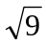 b) 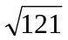 c) 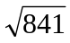

Extra Practice 3
Lesson 1.3: Measuring Line Segments
Master 1.26
1. Simplify.
a) 5² b) c) 8² d)
e) 1² f) 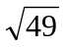 g) 9² h)
2. The area A of a square is given. Find its side length.
Which side lengths are whole numbers?
a) A = 9 cm² b) A = 56 m² c) A = 81 cm²
e) A = 16 m² f) A = 42 cm² g) A = 72 m²
3. Copy each square on grid paper. Find its area.
Then write the side length of the square.
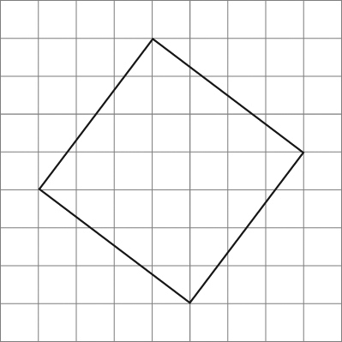
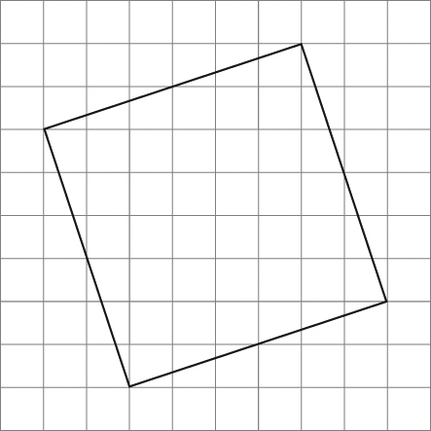
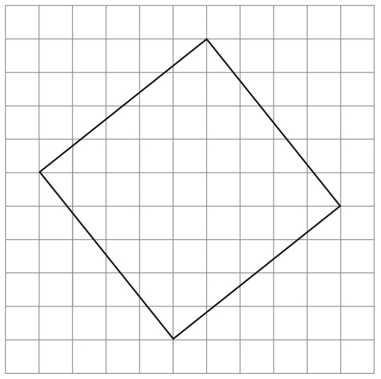
a) b) c)

4. Copy each line segment on grid paper.
Draw a square on each line segment.
Find the area of the square and the length of the line segment.
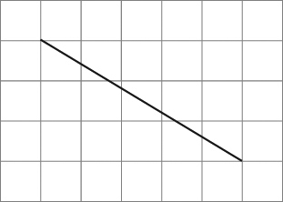
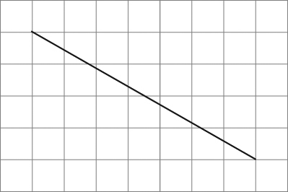
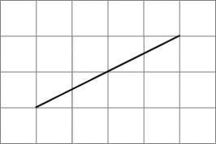
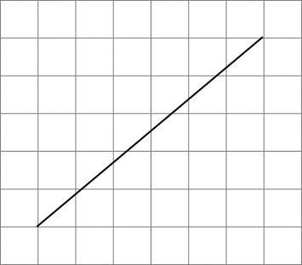
a) b) c) d)

Extra Practice 4
Lesson 1.4: Estimating Square Roots
Master 1.27
1. Use the number line below.
a) Which placements are good estimates of the square roots?
Explain your reasoning.
b) Use the number line to estimate the value of each square root
that is incorrectly placed.
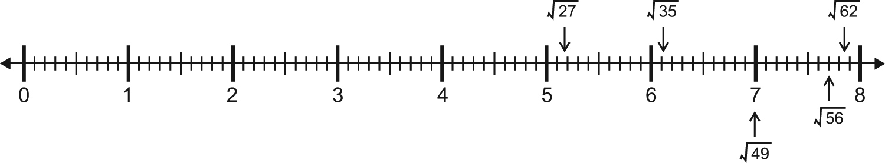

2. a) Which two consecutive numbers is each square root between? How do you know?
b) Use guess and check to estimate the value of each square root to two decimal places.
i) 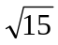 ii) 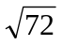
iii) 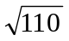 iv) 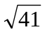
3. Is each statement true or false? Explain.
a) is between 18 and 20.
b) is greater than 10.
c) is less than + 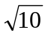.
d) × is less than 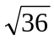.
e) + is less than – .
f) + + is equal to .
4. Chess is played on a square board.
A particular board has an area of about 3250 cm².
What are the approximate dimensions of the board to two decimal places?
5. A farmer has 600 m of fencing.
He wants to enclose a square field of area 24 200 m².
What are the approximate dimensions of the field?
Give your answer to one decimal place.
Does the farmer have enough fencing to enclose the field? Explain.

Extra Practice 5
Lesson 1.5: The Pythagorean Theorem
Master 1.28
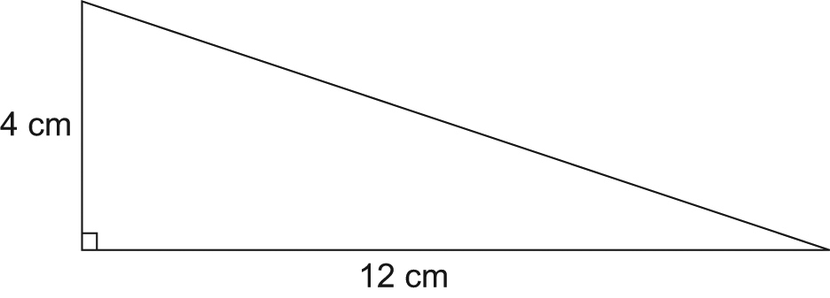
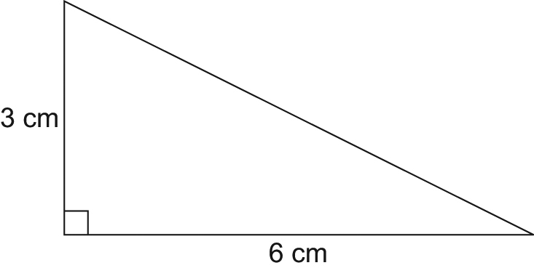
1. Find the length of the unmarked side in each right triangle.
Give your answers to one decimal place.
a) b)

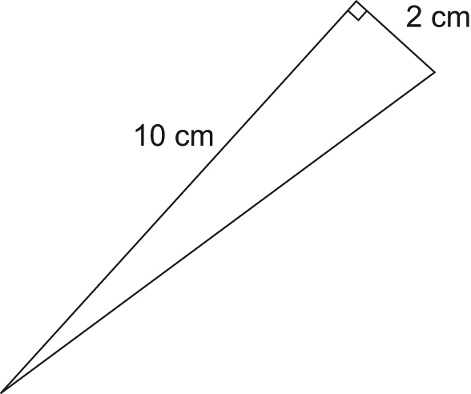
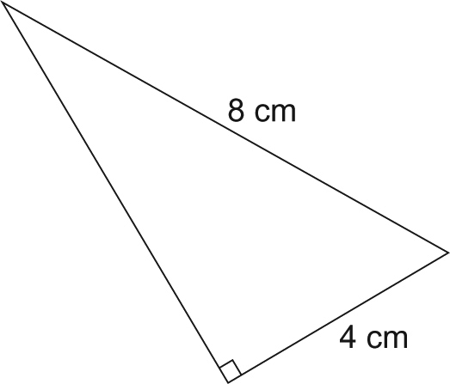
c) d)

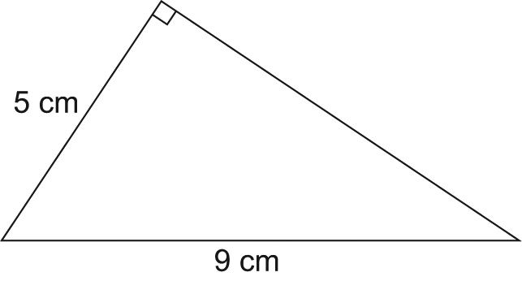
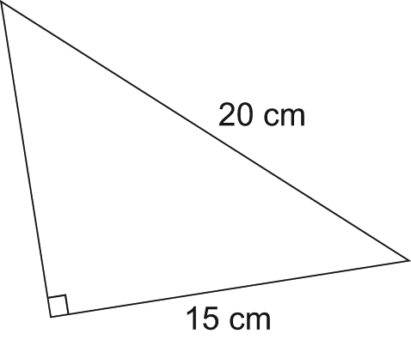
e) f)

2. Find the length of the diagonal, d, in each rectangle.
Give your answers to two decimal places where needed.
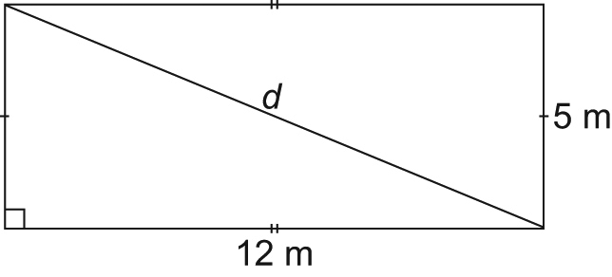
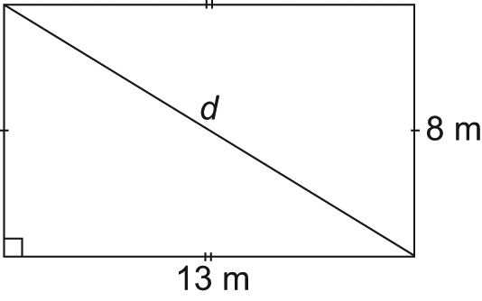
a) b)

3. On grid paper, draw a line segment with each length. Explain how you did it.
a) cm b) cm c) cm
d) cm e) cm f) cm
Extra Practice 6
Lesson 1.6: Exploring the Pythagorean Theorem
Master 1.29
1. Which of the triangles below appears to be a right triangle?
Determine whether each triangle is a right triangle.
Justify your answers.
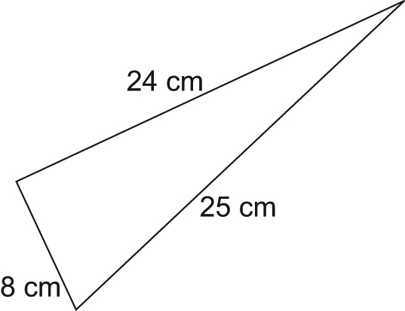
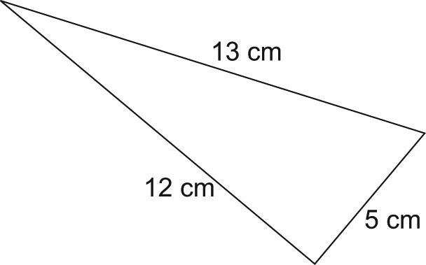
a) b)

2. Each set of measurements below represents the side lengths of a triangle.
Identify which triangles are right triangles.
How do you know?
a) 3 cm, 4 cm, 6 cm
b) 7 m, 24 m, 25 m
c) 6 cm, 8 cm, 10 cm
d) 1 m, 2 m, m
e) 2 m, 3 m, m
3. Which sets of numbers below are Pythagorean triples?
a) 20, 21, 29 b) 11, 34, 35 c) 20, 101, 99 d) 30, 34, 16
4. Two numbers in a Pythagorean triple are 77 and 85.
Find the third number.
5. A triangle has side length of 5 cm, 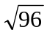 cm and 11 cm.
a) Is this triangle a right triangle?
b) Do these side lengths form a Pythagorean triple? Explain.

Extra Practice 7
Lesson 1.7: Applying the Pythagorean Theorem
Master 1.30
1. Find the length of the unmarked side in each right triangle.
Give your answers to one decimal place.
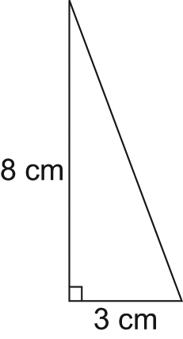
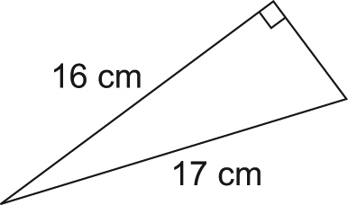
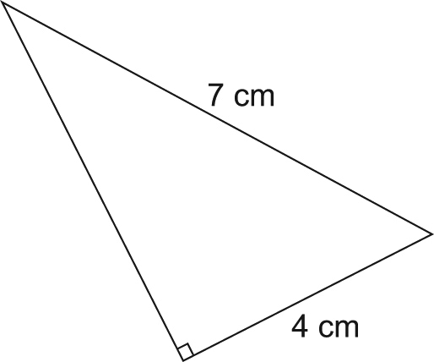
a) b) c)

2. Jovi is laying a foundation for a garage with dimensions 10 m by 6 m.
To check that the foundation is square, Jovi measures a diagonal.
How long should the diagonal be?
Give your answer to one decimal place.
3. A guy wire is 14 m long. It is attached to a TV tower 12 m high.
The guy wire is fastened to a stake in the ground.
How far is the stake from the base of the TV tower?
Give your answer to one decimal place.
4. Petra is building a frame for her window.
The frame is 88 cm wide and 105 cm tall.
She measures the diagonal of her frame and finds that it is 137 cm.
Is the frame a rectangle? Justify your answer.
5. A sloped mountain road is 13 km long.
It covers a horizontal distance of 9 km.
What is the change in elevation of the road?
Give your answer to one decimal place.
6. A cat is stranded in a tree.
You lean a 10-m ladder against the tree.
It is 2 m from the base of the tree.
How far up the tree does the ladder reach?
Give your answer to one decimal place.
Extra Practice Sample Answers
Master 1.31a

Extra Practice 1 – Master 1.24
Lesson 1.1
1. a) 49 square units b) 121 square units
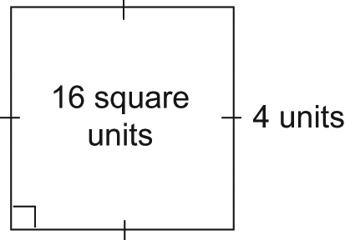
2.

16 = 4 × 4.
A square with area 16 square units has side length
4 units.
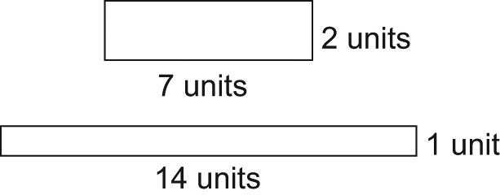
3. a) Not a square. The rectangles with area
14 square units are:

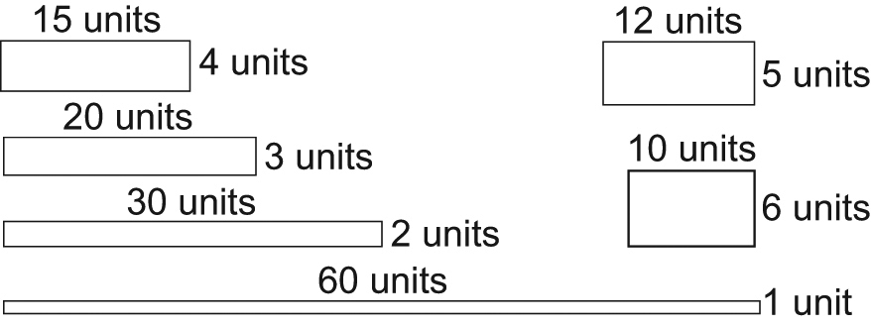
b) Not a square. The rectangles with area 60 square units are:

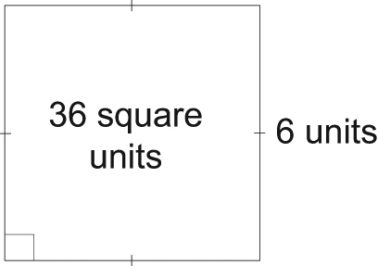
c) A square. I can draw a square with side length
6 units whose area is 36 square units.

4. a) 4 and 9 b) 25 and 36
c) 49 and 64 d) 81 and 100
5. 49
6. a) 15 m by 15 m
b) 60 m
c) 3 strings

Extra Practice 2 – Master 1.25
Lesson 1.2
1. a) 36 b) 121 c) 25
2. a) 7 b) 8 c) 14
3. a) i) 70: 1, 2, 5, 7, 10, 14, 35, 70
Not a square since it has an even number of factors
ii) 144: 1, 2, 3, 4, 6, 8, 9, 12, 16, 18, 24, 36, 48, 72, 144
This is a square since it has an odd number of factors.
iii) 180: 1, 2, 3, 4, 5, 6, 9, 10, 12, 15, 18, 20, 30, 36, 45, 60, 90, 180
Not a square since it has an even number
of factors
b) ii) 12
4. a) Not a square since it has an even number of factors
b) This is a square since it has an odd number of factors. The square root of 196 is 14.
c) This is a square since it has an odd number of factors. The square root of 441 is 21.
5. 576
6. a) 12 b) 15 c) 37
7. a) 9 b) 121 c) 841

Extra Practice Sample Answers continued
Master 1.31b

Extra Practice 3 – Master 1.26
Lesson 1.3
1. a) 25 b) 14
c) 64 d) 15
e) 1 f) 7
g) 81 h) 100
2. a) 3 cm b) 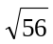 m c) 9 cm
d) 4 m e) 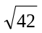 cm f) 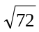 m
The side lengths in parts a, c, and d are
whole numbers.
3. a) 25 square units
b) 40 square units
c) 41 square units
4. a) 34 square units; 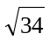 units
b) 65 square units; 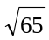 units
c) 20 square units; 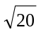 units
d) 61 square units; 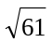 units

Extra Practice 4 – Master 1.27
Lesson 1.4
1. a) 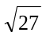: 27 is a bit more than 25 and 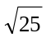 = 5
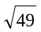: = 7
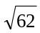: 62 is a bit less than 64 and 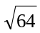 = 8
b) 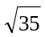: 35 is a bit less than 36 and 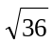 = 6,
so is about 5.9.
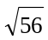: 56 is a about halfway between 49 and 64. = 7 and = 8, so is about 7.5
2. a) i) 15 is between 9 and 16, so 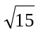 is between 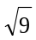 = 3 and 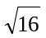 = 4, but closer to 4.
ii) 72 is about halfway between 64 and 81, so is about halfway between
= 8 and 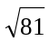 = 9.

iii) 110 is about halfway between 100 and 121, so 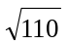 is about halfway between 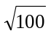 = 10 and 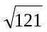 = 11.
iv) 41 is about halfway between 36 and 49, so 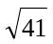 is about halfway between
= 6 and = 7.
b) i) 3.87
ii) 8.49
iii) 10.49
iv) 6.40
3. a) False; 19 is between 16 and 25, so 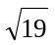 is between = 4 and = 5.
b) True; 10 × 10 = 100, which is less than 101
c) True; 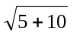 = , which is a little less
than = 4. 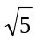 is greater than 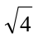 = 2
and 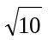 is greater than = 3.
So, + is greater than 2 + 3 = 5.
d) True; 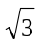 is less than = 2 and 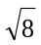 is less than = 3. So, × is less than
2 × 3 = 6. = 6
e) False; 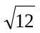 is greater than = 3
and is greater than = 3.
So, + is greater than 3 + 3 = 6.
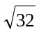 is less than = 6, so – is less than 6 – 3 = 3.
f) False; 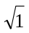 = 1, and + + = 3.
is less than = 2.
So, + + is greater than .
4. About 57.01 cm by 57.01 cm
5. About 155.6 m by 155.6 m
No. The perimeter of the field is:
4 × 155.6 m = 622.4 m

Extra Practice Sample Answers continued
Master 1.31c

Extra Practice 5 – Master 1.28
Lesson 1.5
1. a) About 6.7 cm b) About 12.6 cm
c) About 10.2 cm d) About 6.9 cm
e) About 7.5 cm f) About 13.2 cm
2. a) 13 m b) About 15.26 cm
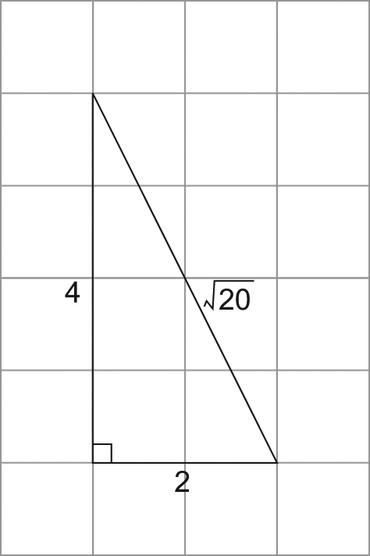
3. I drew a right triangle so that the area of the square on the hypotenuse equalled the sum of the areas of the squares on the legs.
a) 2² + 4² = ()²

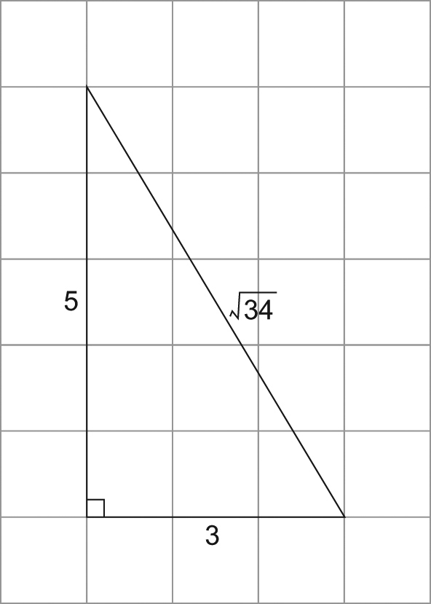
b) 3² + 5² = ()²

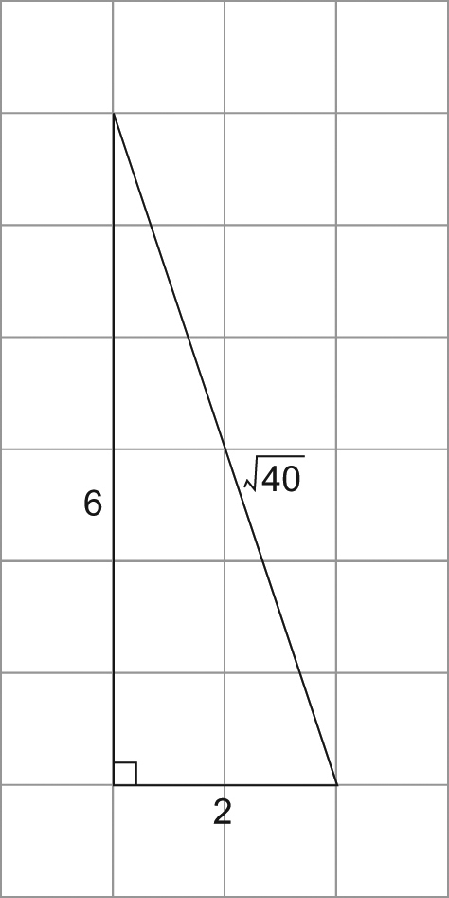
c) 6² + 2² = (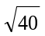)²

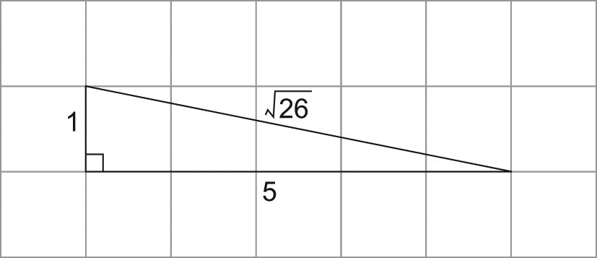
d) 1² + 5² = (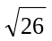)²

Extra Practice Sample Answers continued
Master 1.31d

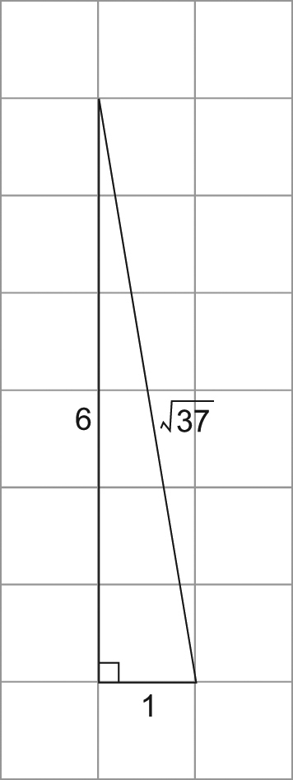
e) 6² + 1² = (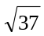)²

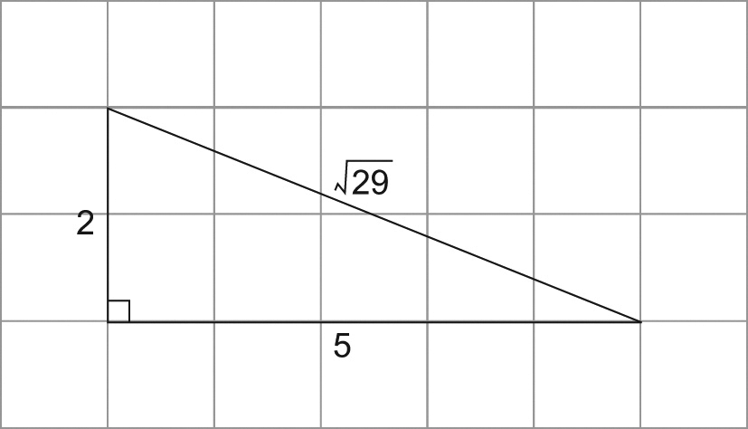
f) 2² + 5² = (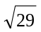)²

Extra Practice 6 – Master 1.29
Lesson 1.6
1. a) Does 8² + 24² = 25²?
L.S. = 8² + 24² = 64 + 576 = 640
R.S. = 25² = 625
No, 640 ≠ 625
So, the triangle is not a right triangle.
b) Does 12² + 5² = 13²?
L.S. = 12² + 5² = 144 + 25 = 169
R.S. = 13² = 169
Yes, 169 = 169
So, the triangle is a right triangle.
2. The right triangles are the triangles in
b, c, and d.
a) Does 3² + 4² = 6²?
L.S. = 3² + 4² = 9 + 16 = 25
R.S. = 6² = 36
No, 25 ≠ 36
b) Does 7² + 24² = 25²?
L.S. = 7² + 24² = 49 + 576 = 625
R.S. = 25² = 625
Yes, 625 = 625
c) Does 6² + 8² = 10²?
L.S. = 6² + 8² = 36 + 64 = 100
R.S. = 10² = 100
Yes, 100 = 100
d) Does 1² + 2² = ()²?
L.S. = 1² + 2² = 1 + 4 = 5
R.S. = ()² = 5
Yes, 5 = 5
e) Does 2² + 3² = ()²?
L.S. = 2² + 3² = 4 + 9 = 13
R.S. = ()² = 12
No, 13 ≠ 12
3. The Pythagorean triples are the sets in a, c, and d.
4. 36
5. a) Yes, it is a right triangle. 5² + (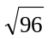)² = 11²
b) They do not form a Pythagorean triple since is not a whole number.

Extra Practice 7 – Master 1.30
Lesson 1.7
1. a) About 8.5 cm
b) About 5.7 cm
c) About 5.71 cm
2. About 11.7 m
3. About 7.2 m
4. Does 88² + 105² = 137²?
L.S. = 88² + 105² = 7744 + 11 025 = 18 769
R.S. = 137² = 18 769
Yes, 18 769 = 18 769
So, the frame is a rectangle since its corners form right angles.
5. About 9.4 km
6. About 9.8 m

