Grade 8 Novel Study

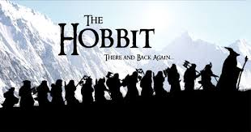

Teacher: Mr Farquharson
Name: ____________________________________

