Summarized Outcomes across Areas of Study
for Grades 6-9
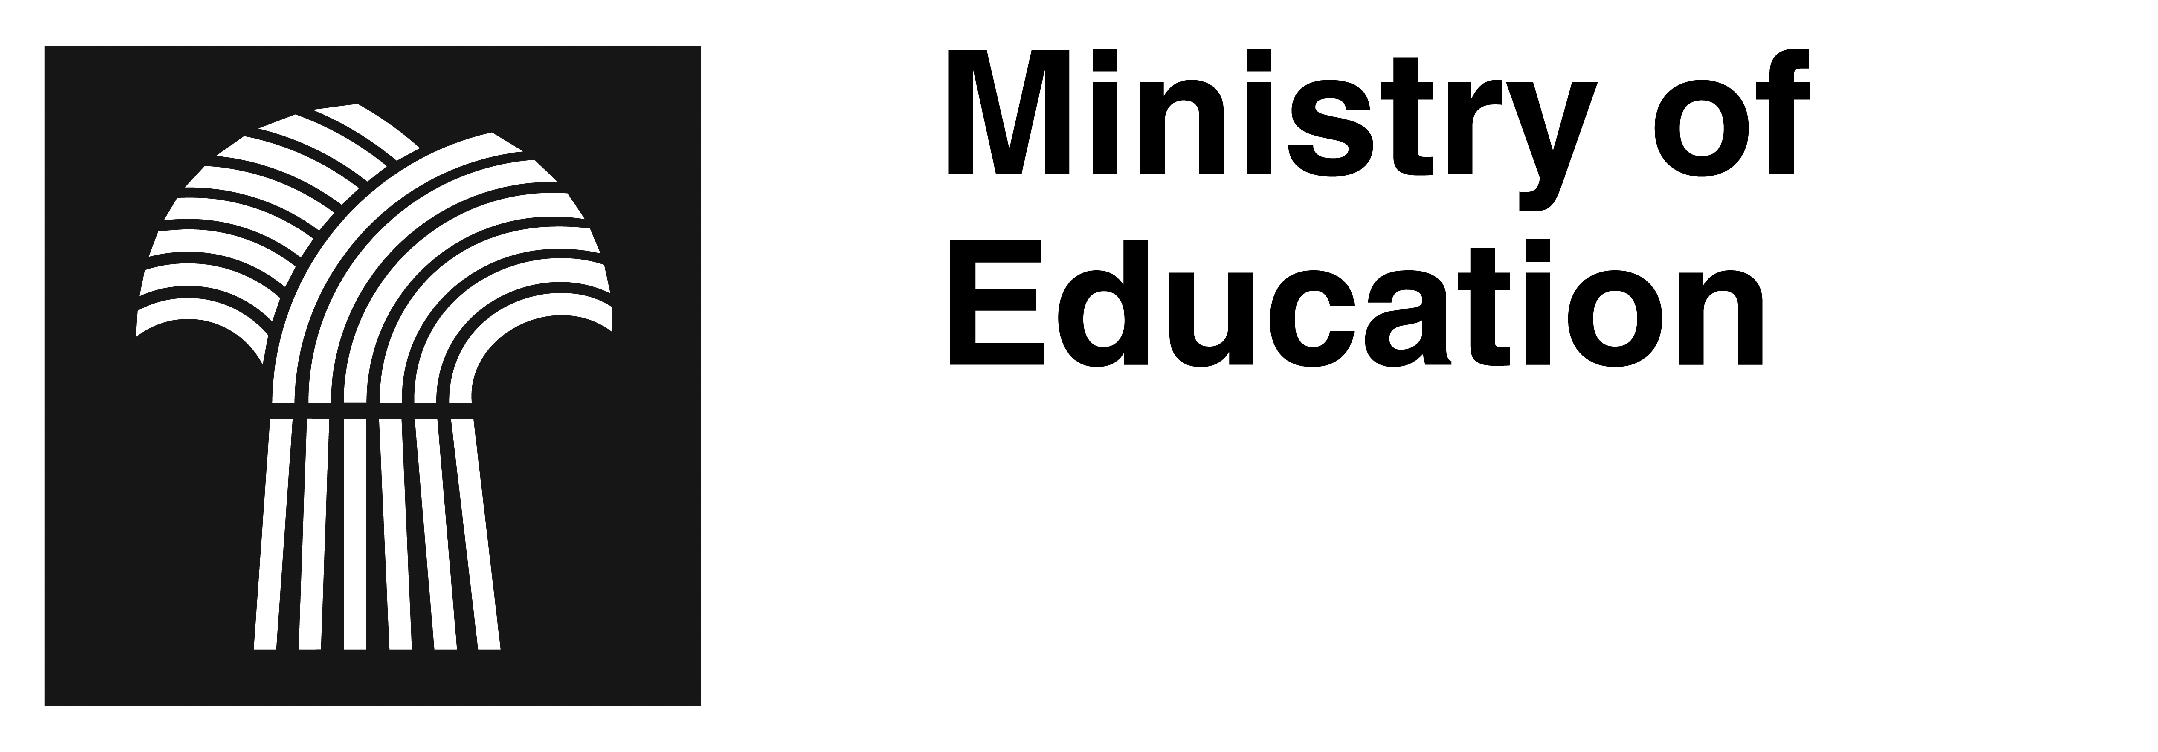

February 2013

Arts Education

Mathematics

K-12 Goals: logical thinking, number sense, spatial sense, and mathematics as a human endeavour. | Grade 6 | Grade 7 | Grade 8 | Grade 9
Number Strand | - Demonstrate understanding of place value for numbers greater than 1 million and less than one thousandth.  - Demonstrate understanding of factors and multiples of numbers less than 100, relating factors and multiples to multiplication and division, and determining and relating to prime and composite numbers.  - Demonstrate understanding of the order of operations on whole numbers.  - Extend understanding of multiplication and division to decimals.  - Demonstrate understanding of percent.  - Demonstrate understanding of Integers.  - Extend understanding of fractions to improper fractions and to mixed numbers.  - Demonstrate an understanding of ratio.  - Research and present how First Nations and Métis peoples envision, represent, and use quantity. | - Demonstrate an understanding of division through the development and application of divisibility strategies for 2, 3, 4, 5, 6, 8, 9, and 10, and involving zero.  - Expand and demonstrate an understanding of addition, subtraction, multiplication, and division of decimals to greater numbers of places, and the order of operations.  - Demonstrate an understanding of the relationships between positive decimals, positive fractions, and whole numbers.  - Expand and demonstrate an understanding of percent including fractional percents between 1% and 100%.  - Demonstrate an understanding of adding and subtracting positive fractions and mixed numbers, with like and unlike denominators.  - Demonstrate an understanding of addition and subtraction of integers. | - Demonstrate an understanding of square and principle square root of whole numbers.  - Expand and demonstrate an understanding of percents greater than or equal to 0%.  - Demonstrate an understanding of rates, ratios, and proportional reasoning.  - Demonstrate an understanding of multiplying and dividing positive fractions and mixed numbers.  - Demonstrate an understanding of multiplication and division of integers. | - Demonstrate an understanding of powers with integral bases (excluding base 0) and whole number exponents.  - Demonstrate an understanding of rational numbers.  - Extend understanding of square roots to include the square root of positive rational numbers.
Patterns and Relations Strand | - Extend understanding of patterns and relationships in tables of values and graphs.  - Extend understanding of preservation of equality.  - Extend understanding of patterns and relationships using expressions and equations involving variables. | - Demonstrate an understanding of the relationships between oral and written patterns, graphs, and linear relations.  - Demonstrate an understanding of equations and expressions.  - Demonstrate an understanding of one-and two-step linear equations.  - Demonstrate an understanding of linear equations by modeling problems as a linear equation and solving the problems. | - Demonstrate an understanding of linear relations.  - Model and solve problems using linear equations. | - Demonstrate an understanding of linear relations.  - Model and solve situational problems using linear equations  - Demonstrate an understanding of single variable linear inequalities with rational coefficients.  - Demonstrate an understanding of polynomials.
Shape and Space Strand | - Demonstrate an understanding of angles.  - Extend and apply understanding of perimeter of polygons, area of rectangles, and volume of right rectangular prisms.  - Demonstrate an understanding of regular and irregular polygons.  - Demonstrate an understanding of the first quadrant of the Cartesian plane and ordered pairs with whole number coordinates.  - Demonstrate an understanding of single and combinations of transformations of 2-D shapes. | - Demonstrate an understanding of circles including circumference and central angles.  - Develop and apply formulas for determining the area of triangles, parallelograms, and circles.  - Demonstrate an understanding of 2-D relationships involving lines and angles.  - Demonstrate an understanding of Cartesian plane and ordered pairs with integral coordinates.  - Expand and demonstrate an understanding of transformations 2-D shapes in all four quadrants of the Cartesian plane. | - Demonstrate an understanding of the Pythagorean Theorem.  - Demonstrate an understanding of the surface area of 3-D objects limited to right prisms and cylinders.  - Demonstrate an understanding of volume limited to prisms and cylinders.  - Demonstrate an understanding of tessellation. | - Demonstrate an understanding of circle properties.  - Extend understanding of area to surface area of right rectangular prisms, right cylinders, right triangular prisms, and composite 3-D objects.  - Demonstrate an understanding of similarity of 2-D objects.  - Demonstrate an understanding of line and rotation symmetry.
Statistics and Probability Strand | - Extend understanding of data analysis.  - Demonstrate an understanding of probability. | - Demonstrate an understanding of the measures of central tendency and range for sets of data.  - Demonstrate an understanding of circle graphs.  - Demonstrate an understanding of the theoretical and experimental probabilities for two independent events where the combined sample space has 36 or fewer elements. | - Analyze the modes of displaying data and the reasonableness of conclusions.  - Demonstrate an understanding of the probability of independent events. | - Demonstrate an understanding of various factors affecting data collection.  - Demonstrate an understanding of collection, display, and analysis of data.  - Demonstrate an understanding of the role of probability in society  - Research and present how First Nations and Métis peoples envision, represent, and make use of probability and statistics.

Refer to curriculum for complete outcomes and indicators.

