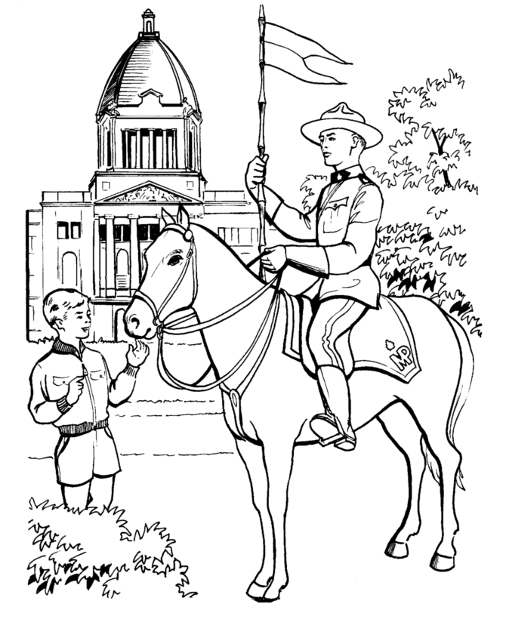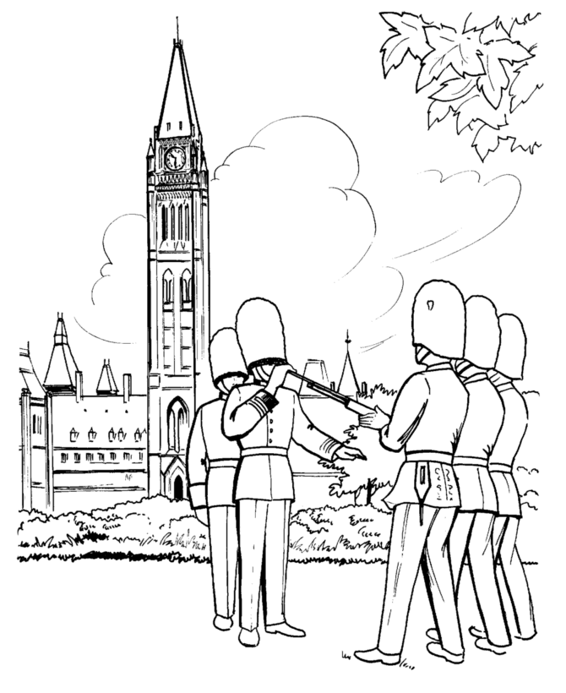

Student Name:

__________________

Teacher: Mr. G. Farquharson

**Grade 8**

**Social Studies**

**Unit 8**

**Government in Canada**