Geometry 3D Shapes Name______________
Using your phone, Ipad or Chromebook
Go to https://www.learner.org/interactives/geometry/index.html
Introduction
In a Three Dimensional (3D) world every object can be measured three ways by:
___________________ ___________________ ___________________
3D Shapes
- Definitions – explore this page and it’s links to find definitions for each of the following.
- Polygon

- Polyhedron

- Face

- Edge

- Vertex or Vertices

- Lable each of the above on the Cube below.

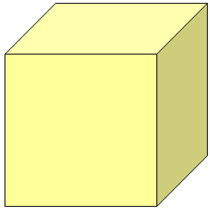

- Exploring and Playing with Prims
Number of :
Name ____________________ Net Diagram Faces Vertices Edges

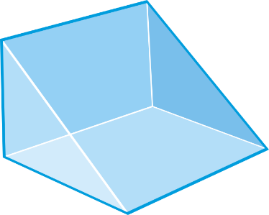
Number of :
Name ____________________ Net Diagram Faces Vertices Edges
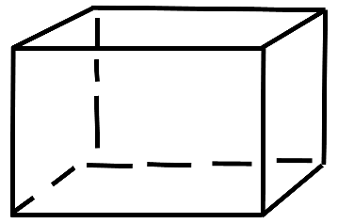

Number of :
Name ____________________ Net Diagram Faces Vertices Edges

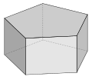
Number of :
Name ____________________ Net Diagram Faces Vertices Edges
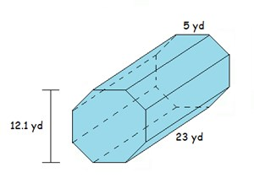

- Explore and Play with Pyramids
Number of :
Name ____________________ Net Diagram Faces Vertices Edges
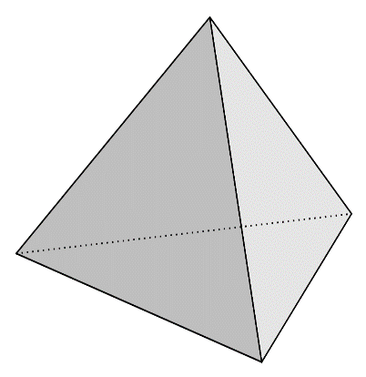
Number of :
Name ____________________ Net Diagram Faces Vertices Edges

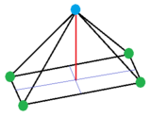 Number of :
Name ____________________ Net Diagram Faces Vertices Edges

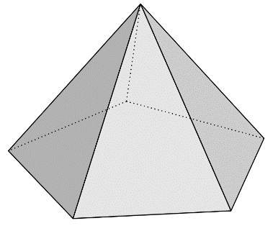
Number of :
Name ____________________ Net Diagram Faces Vertices Edges
