Climate Change: Time To Act
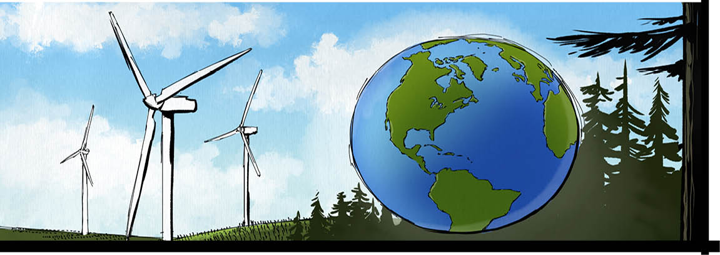

The Intergovernmental Panel on Climate Change (IPCC) has completed its seven-year task. In April, it delivered the last of three reports on climate change.
The first report, released in September 2013, laid out the evidence for climate change. It noted that “warming of the climate system is unequivocal.” The second, completed on March 31, 2014, assessed the impacts of climate change on every part of the globe, and analyzed future risks. The report that was finalized on April 11 addressed options for diminishing the effects of climate change.
The IPCC’s Role
The three reports were written to lay the groundwork for governments so they can make decisions about how best to tackle global warming.
Scientists agree that global mean temperatures must not rise higher than two degrees Celsius above the levels they were at in 1800. That would help the Earth avoid the most catastrophic impacts of climate change.
The IPCC reports show that to have a chance of staying within this limit, we must lower global greenhouse gas emissions by 40 to 70 percent of 2010 levels by 2050, and to near-zero by the end of the century.
The Plan
How can this be accomplished? By cutting emissions. That means moving away from polluting fossil fuels, switching to low-carbon, renewable energy sources, slowing deforestation and planting new forests, and making improvements to transportation, industrial processes and buildings.
“You can design buildings that use one half or less of the energy of buildings recently built for no extra cost,” said Danny Harvey, a University of Toronto climate scientist and one of the Canadian lead authors of the report.
At the same time, governments must ensure that economic growth and rising populations do not lead to more greenhouse gas emissions. How? By developing new technologies, and improving designs for and access to clean energy sources. It can be done.
“So many of the technologies that will help us fight climate change are far cheaper, more readily available and better performing than they were when the last IPCC assessment was released less than a decade ago,” said U.S. Secretary of State John Kerry.
Business As Usual
What if we don’t shift direction and significantly reduce our output of heat-trapping greenhouse gases? What if we continue on our current course?
If no changes are made, the IPCC warns that the planet could warm by roughly four degrees Celsius by the end of this century. That would be costly for the developed world, and potentially catastrophic for poorer nations that cannot adjust.
We would see more of what we are already seeing: warming oceans, shrinking ice sheets, and rising sea levels. The scenario also includes flooding, droughts and other climate impacts. The results could devastate economies, food and water supplies, agriculture and human health.
On To Paris, 2015
To avoid this, negotiators from around the world are drafting an all-important global deal on climate change to be signed in Paris in December, 2015. However, getting all countries to agree on a plan won’t be easy.
The biggest roadblock to a climate change treaty? Money. Countries need to agree on who will pay for the measures needed to slow global warming and help poorer nations adapt to the impacts of climate change.
Developing countries such as India, China and Brazil that are striving to improve their standard of living are responsible for most of the current increase in fossil fuel use. So, richer nations say they need to share the financial burden of implementing a treaty even they don’t have as great an ability to pay. Meanwhile, these developed nations, including the United States, Canada, Germany and Japan, are responsible for the bulk of the greenhouse gas emissions currently in the atmosphere. They also have more money – and so must take on a large share of the costs, even if in recent years they’ve been cutting emissions.
The Next Step
Progress towards a new international agreement will no doubt be bumpy. However, the IPCC reports show that a new, more sustainable course is vital.
As IPCC chair Rajendra Pachauri put it, “The high-speed mitigation train needs to leave the station very soon, and all of global society needs to get on board.”

What’s The Problem?
The Earth is supposed to be warm. Heat-trapping, or ‘greenhouse’ gases exist naturally in the air around the Earth. There, they trap and hold the sun’s heat. This warms our planet and makes life possible.
The problem, however, is that this natural warming system – known as the greenhouse effect – has been thrown out of balance over the last 200 years. More greenhouse gases are gathering in the atmosphere than naturally exist there. As a result, the Earth is warming faster than it ever has before.
What’s causing this imbalance? Humans. By burning fossil fuels to run cars, heat homes, and make products, people are putting greenhouse gases into the atmosphere. Rotting garbage also gives off methane gas, one of the most potent greenhouse gases. And cutting down trees, which absorb these emissions, makes the problem worse.

Did You Know?
To compile these IPCC reports, hundreds of the world’s leading scientists from dozens of countries sifted through thousands of scientific studies. For example, the most recent report included contributions from 235 authors and 38 editors. As well, 180 experts gave additional input and more than 800 others reviewed drafts.

The Emissions Story
According to the IPCC reports, global emissions have risen to unprecedented levels – in spite of some efforts to reduce them. In fact, emissions grew more quickly between 2000 and 2010 than in each of the three previous decades. Levels of greenhouse gases in the atmosphere have increased in amounts not seen in at least 800,000 years. And the oceans have absorbed 30 percent of carbon dioxide emissions, causing ocean acidification.
China, with the world’s largest population, is responsible for over 20 percent of global emissions. The United States is the second-largest producer of greenhouse gases, followed by India, Russia, Japan, Germany, and Iran. Lightly-populated Canada is in eighth place, responsible for less than two percent of global carbon emissions.
However, the amount of emissions produced by each country doesn’t tell the whole story. Canadians and other citizens of developed countries that have been scaling back their emissions in recent years consume products made in places such as China. If emissions were tagged to the countries consuming products that generate greenhouse gases, the picture would be very different.
Seen that way, “we have not reduced our emissions at all. We’ve exported dirty industries to the developing world,” says Jake Rice, a lead author on the report and chief scientist with Fisheries and Oceans Canada.

acidification: the process of becoming acid or being converted into an acid
deforestation: clearing forests of trees
Intergovernmental Panel On Climate Change: a UN-backed scientific group put together by the governments of many countries to provide governments and their decision-makers with a summary of the latest climate science
mean: occurring midway between the highest and lowest number
mitigation: the action of reducing the severity, seriousness, or painfulness of something
unequivocal: leaving no doubt

On The Lines Answer the following in complete sentences:
1. What is the greenhouse effect?
2. How has the Earth’s natural warming system been thrown out of balance over the last 200 years?
3. List at least four ways that scientists say global warming will impact the planet.
4. What does IPCC stand for and what is the purpose of this panel?
5. Briefly explain the three IPCC reports concerning climate change and explain why these were written.
6. What do scientists say must happen if Earth is to avoid the most catastrophic effects of global warming?
7. What reductions to greenhouse gas emissions must be achieved in order to achieve this goal?
8. List at least three strategies for cutting greenhouse gas emissions.

Between The Lines
An inference is a conclusion drawn from evidence. A plausible inference is supported by evidence in the article and is consistent with known facts outside of the article.
What inference(s) can you draw from the fact that carbon emissions grew more quickly between 2000 and 2010 than in each of the three previous decades?

Beyond The Lines
1. There are some pretty exciting and high-tech strategies for reducing our carbon emissions. Learn about three that you’ve never heard of before. Which do you see as having the greatest potential? Explain your choice.
2. Read up on nuclear power. Is it time to embrace this low carbon method of generating energy?

Just Talk About It
1. Many problems can be solved by single nations and their leaders. However, some problems, such as climate change, lead nations to believe that “doing the right thing” will cost them in the great economic race against other nations. They may also believe it would cost them votes. In some movies that depict the Earth of the future, there is a single president of the world. Do you think we should have such a person? Imagine that is your job. How would you ensure that all nations follow the advice of the IPCC ? How would you save the world from the worst consequences of climate change?
2. Almost everything you purchase, from food to clothes to video games, has a carbon cost. Should a carbon tax be placed on much of what we buy in order to fund the research and development of renewable technologies? Would switching to these technologies cost jobs, or create them?

On-Line
Visit our student website at www.news4youth.com and click on the What in the World? tab to:
1. Learn from environmental icon David Suzuki what you can do to reduce your carbon footprint (or visit http://www.davidsuzuki.org/what-you-can-do/reduce-your-carbon-footprint/?gclid=COPnq9iYhr4CFZNlOgodNVYAkA).
2. Watch the humorous cartoon explanation of climate change from Al Gore’s Academy Award winning documentary, An Inconvenient Truth (or visit https://www.youtube.com/watch?v=OqVyRa1iuMc).
3. Find out how many Canadians still deny the existence of climate change, then cast your own vote (or visit http://www.cbc.ca/news/canada/calgary/only-2-of-canadians-deny-climate-change-suggests-poll-1.1157215).

Quiz

Climate Change
Write the letter that corresponds to the best answer on the line beside each question:
______ 1. The Earth’s natural warming system is called:
a) global warming b) solar power
c) climate change d) carbon footprint
e) greenhouse effect
______ 2. Which country is the world’s largest polluter?
a) Germany b) United States
c) Russia d) China
e) Mexico
______ 3. Where will the next major conference on climate change take place in 2015?
a) Paris b) Toronto
c) Beijing d) Moscow
e) New York
______ 4. True or False? Money is the largest obstacle to a new international climate change agreement.
______ 5. True or False? Carbon emissions have been slowing down over the past decade.
6. All governments should be very concerned about global warming. Do you agree or disagree with this statement? Give reasons to support your response.

